James Johnson  
ME 4813  
EB 3.04.22

December 7, 2016

Professor Johnson,

Please review the attached Final Report for The Roadrunner Robot 2: The Rimless Wheeled Robot project.

Sincerely,  


Aspen Meineke   
ABC Ngineering Team Lead

*ME 4813 SENIOR DESIGN 2*



**ABC Ngineering**

**Final Report**

Date Submitted: 07 December 2016

Time: 1700 hours

By:

Noel Cantu

James Crisler

Bianca Dumlao

Aspen Meineke

*In Partial Fulfillment for the Requirements of Senior Design 2*

*University of Texas at San Antonio Department of Mechanical Engineering.*

# Abstract

When NASA sends rovers to Mars, traditional tires are unreliable due to the sharp and rugged terrain of the planet. This is why it is important to study alternative methods of transportation such as rimless wheels. Rimless wheels combine the ease and energy efficiency of a normal wheel with the flexibility of legged locomotion. The purpose of the Roadrunner Robot 2 (RR2) is to design a rimless wheeled robot capable of achieving a speed of 5 miles per hour and a turning radius of 5 feet. A differential drive system was used with 10 spokes on each wheel to increase the stability. Arduino Mega 2560, Xbee shield and Xbee antennas with a Zigbee protocol were used to remotely control the robot. In testing the RR2 was able to achieve a minimum speed of 5 miles per hour while traveling straight. The RR2 was able to complete a 5-foot turning radius and could be controlled from a distance of 50 feet. ABC Ngineering worked under the mentorship of Dr. Pranav Bhounsule to design, analyze, build, and test the RR2 to further research for the Robotics and Motions Laboratory at The University of Texas at San Antonio.

Table of Contents

Acronyms i

1.0 Introduction 1

1.1 Importance of Proposed Research 1

1.2 Rimmed Wheels 2

1.3 Legged Locomotion 2

1.4 Rimless Wheels 2

1.5 Previous Research on Rimless Wheel Robots 3

2.0 Purpose 3

3.0 Objectives 3

4.0 Engineering Design Specifications 4

4.1 Identification of Functional Requirements 4

4.2 Physical Specifications 4

4.3 Performance Specifications 5

5.0 Concepts and Selection 6

5.1 Concept 1 – Independently Actuated Legs 6

5.2 Concept 2 – Steering Rack 8

5.3 Concept 3 – Varying Wheel Radius 10

5.4 Final Concept Selection Method 12

6.0 Final Design 13

6.1 Key Features 13

6.2 Estimated Performance 17

6.3 Material Selection and Justification 17

6.4 Assemblies and Parts 18

7.0 Prototype Fabrication 19

7.1 Fabrication Methods 19

7.2 Prototype Fabrication Drawings 19

7.3 Bill of Materials 19

8.0 Prototype Tests 21

8.1 Test Plan Summary 21

8.2 Test Setup 22

8.3 Test Results 22

9.0 Project Management 24

9.1 Schedule 24

9.2 Financial Performance 29

10.0 Project Conclusions 30

References 32

Appendix A – Theory of Operations Manual A1

Appendix B – Test Plan B1

Appendix C – Test Report C1

Appendix D – Design Drawings D1

Appendix E - Calculations E1

**List of Figures**

Figure 1. Roadrunner Robot 1 1

Figure 2. Rimless Wheel [5] 3

Figure 3. Concept 1 – Independently Actuated Legs 6

Figure 4. Exploded View of Concept 1- Independently Actuated Legs 7

Figure 5. Concept 2 - Steering Rack 8

Figure 6. Isometric View of Concept 3 – Varying Wheel Radius 10

Figure 7: Exploded View of Concept 3 – Varying Wheel Radius 11

Figure 8. Electrical System 15

Figure 9. Software Diagram 16

Figure 10. Roadrunner Robot 2 - Top Assembly 18

Figure 11. Work Breakdown Schedule 1 26

Figure 12. Work Breakdown Schedule 2 26

Figure 13. Work Breakdown Schedule 3 27

Figure 14. Work Breakdown Schedule 4 27

Figure 15. Work Breakdown Schedule 5 28

Figure 16. Work Breakdown Schedule 6 28

Figure 17. Work Breakdown Schedule 7 29

Figure 18. Work Breakdown Schedule 8 29

Figure 19. Project Labor Cost 29

Figure 20. Spoke Effectiveness E6

**List of Tables**

Table 1. Pugh Chart 12

Table 2. Bill of Materials 19

Table 3: Compliance Matrix 21

Table 4. Test T-1 Data 22

Table 5. Test T-2 Data 22

Table 6. Test T-3 Data 22

Table 7. Test T-4 Data 23

Table 8. Test T-5 Data 23

Table 9. Test T-6 Data 23

Table 10. Test T-7 Data 24

Table 11. Moment of Inertia E4

Table 12. Angular Velocity E5

**List of Equations**

Equation 1. Concept 1 Turning Radius Calculations E1

Equation 2. Concept 2 Turning Radius Calculations E1

Equation 3. Concept 3 Turning Radius Calculations E2

Equation 4. Speed Calculations E2

Equations 5 and 6. Mass Moment of Inertia E3

Equation 7. Angular Velocity E3

Equation 8. Rotational Energy E3

Equation 9. Estimated Battery Usage Calculations E3

Equation 10. Schedule Variance E6

Equation 11. Cost Variance E6

Equation 12. Schedule Performance Index E7

Equation 13. Cost Performance Index E7

Equation 14. Cost Schedule Index E7

# Acronyms

RR2 Roadrunner Robot 2

ESC Electronic Speed Control

ft Length/distance (feet)

in Length/distance (inches)

lbs Weight (pounds)

mph Linear speed (miles per hour)

rpm Angular speed (revolutions per minute)

IMU Inertial Measurement Unit

3D 3 Dimensional

# 1.0 Introduction

## 1.1 Importance of Proposed Research

Currently, the NASA Curiosity Rover is on Mars and there have been issues with the tires, due to the rough terrain of the planet. Since Mars has sharp rocks like spikes, the tires can be “dented, punctured and even torn,” which can cause damage to the rover [4]. This is why it is important to study alternative methods of transportation, such as rimless wheels, which can travel over rocks instead of going through them. The idea for this project is a continuation from a previous senior design project that was completed at The University of Texas at San Antonio in Spring 2015. The previous project was called the Roadrunner Robot 1 (RR1) and was designed by the team, Force Over Area. The RR1 is a legged robot that achieves locomotion using a rimless wheel design. ABC Ngineering will be designing the Roadrunner Robot 2, which will be a continuation of the project done by Force Over Area.

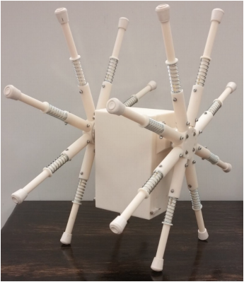

## Figure 1. Roadrunner Robot 1

The goal of this project is to further the research of rimless wheels, before this robot is able to be utilized for other purposes. Possible applications of this robot include locomotion over rough terrain such as a rover on land, lunar, or Martian surfaces.

## 1.2 Rimmed Wheels

Wheeled locomotion has been used for thousands of years for transportation. Rimmed Wheeled locomotion is the preferred method of most transportation because of its simplicity, efficiency and reliability. These traits has allowed for advancements of modern technology. Wheels reduce the amount of friction caused when moving an object across a surface. This allows objects to be moved using less energy. One of the deficiencies of a rimmed wheel is its ability to maneuver over rough and uneven terrain.

## 1.3 Legged Locomotion

Legged locomotion combines the biology of a human walking with robotics and is the interaction between the legs of the system and the environment [7]. When humans walk they show great control over their movements and have the mobility to adjust moment when encountering an obstacle in its path or adjust to irregular terrain. This method of movement shows great control of movement, dexterity and stability [6]. However, it is still unknown how humans accomplish this, which is why the study of legged locomotion is so imperative. Legged locomotion is used for movement over rough or uneven terrain, which is quite difficult for traditional rigid robots.

## 1.4 Rimless Wheels

The rimless spoked wheel resembles legged locomotion and mimics the mechanical features of a human walking such as foot collisions, falling-and-catching, and inverted pendulum behavior when the spoke comes in contact with the ground [2]. The rimless wheel has a hub, which is surrounded by spokes with a fixed angle between them. By being able to control the dynamic motion of the robot, this could lead to a significant decrease in the energy required by the system, which would increase the rimless wheels efficiency [1].

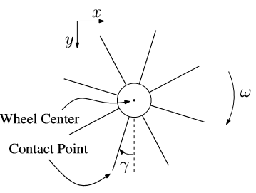

## Figure 2. Rimless Wheel [5]

## 1.5 Previous Research on Rimless Wheel Robots

The previous design of this robot, the RR1, was capable of linear locomotion at a maximum speed of 4.09 miles per hour. This design included two rimless wheels, 8 spokes on each wheel, and a spring in each spoke to absorb the energy from the inelastic collision with the ground.

Rimless wheel robots are designed as rovers for rough terrain. Rovers often have wheels without smooth, circular perimeters. The added capability of legged locomotion allows the rover to facilitate traction and move about uneven surfaces [5].

# 2.0 Purpose

The purpose of the Roadrunner Robot 2 (RR2) is to design a rimless wheeled robot capable of achieving a speed of 5 miles per hour and a turning radius of 5 feet. This robot will be used in the Robotics and Motions Lab to further research focusing on legged locomotion.

# 3.0 Objectives

The objective of this project is to build and test a rimless wheeled robot capable of the desired speed and turning radius. This will be fulfilled by turning in reports that will contain the detailed design and drawings, analysis and calculations, fabrication plan, testing plan, and cost analysis to ensure that the robot meets the specifications. Presentations will also be given, which will be supplemented by PowerPoint slides and a poster.

# 4.0 Engineering Design Specifications

The specifications, below, were defined by our sponsor and mentor, Dr. Pranav Bhounsule. The dimensions set were based on keeping the robot portable and able to be transported by the average human.

## 4.1 Identification of Functional Requirements

The rimless wheeled robot must be able to achieve a speed of 5 miles per hour and a turning radius of 5 feet. The structure of the robot must be strong enough to withstand the impact forces absorbed at this speed. The robot must be able to be controlled by a remote control up to a distance of 50 feet.

## 4.2 Physical Specifications

### 4.2.1 Dimensions

The dimensions of the robot will allow for portability and easy transportation. The robot must be able to fit in the trunk of a car without being disassembled.

#### 4.2.1.1 Radius

The radius of the robot’s wheel must not exceed 2 feet. The radius will be measured from the center of the wheel hub to the outer radial edge of the wheel.

#### 4.2.1.2 Width

The width of the robot must not exceed 1.5 feet. The width will be measured from outer edge of each wheel hub.

### 4.2.2 Weight

The weight of the robot, including all its components, should not exceed 20 pounds.

### 4.2.3 Number of legs

The robot must consist of at least 3 legs per wheel.

### 4.2.4 Material

The material must be able to withstand the impact forces while the robot is operating.

### 4.2.5 Soldering

Soldering may be necessary to install electrical components.

## 4.3 Performance Specifications

### 4.3.1 Motor

The motor must be capable of producing a speed of 5 miles per hour.

### 4.3.2 Microcontroller

The microcontroller will be used to receive commands from the robot operator through radio frequency. It will output speed and control commands to the motors through the ESC (electronic speed controller).

#### 4.3.2.1 Memory

The memory of the microcontroller must be large enough to store programs needed to control the robot. It must have the necessary capacity to hold programs, power the motor through current control, communicate between the remote controller and the receiver, and record performance information on the robot.

#### 4.3.2.2 Power Limitations

The microcontroller must be able to withstand voltages provided to it from all other components.

### 4.3.3 Remote Control

The remote control must communicate with the robot from a distance exceeding 50 feet. The remote control must have sufficient capabilities to stop the motor, increase motor speed, decrease motor speed, and control turning operations.

### 4.3.4 Power Supply

A rechargeable battery will be used to power the robot.

### 4.3.5 Spring System

The legs of the robot must be able to absorb the forces from impact when hitting the ground to minimize energy loss.

### 4.3.6 Turning

The robot must be able to turn at a radius of 5 feet. The radius will be measured from the origin of the turn to the outer hub.

### 4.3.7 Speed

The robot must be able to travel straight at 5 miles per hour for 100 feet.

# 5.0 Concepts and Selection

## 5.1 Concept 1 – Independently Actuated Legs

### 5.1.1 Introduction

Differential drive is when the two wheels are controlled by different motors to allow for them to operate at different speeds and it used for lighter robots. By having wheel speeds that are independently controlled one wheel can be slowed down and the second wheel can increase in speed allowing for the faster wheel to turn around the slower one. The proposed design is shown in the figure below.

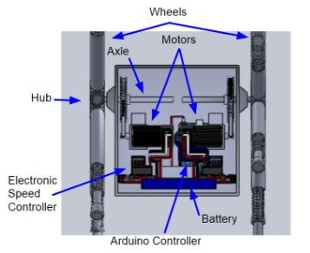

## Figure 3. Concept 1 – Independently Actuated Legs

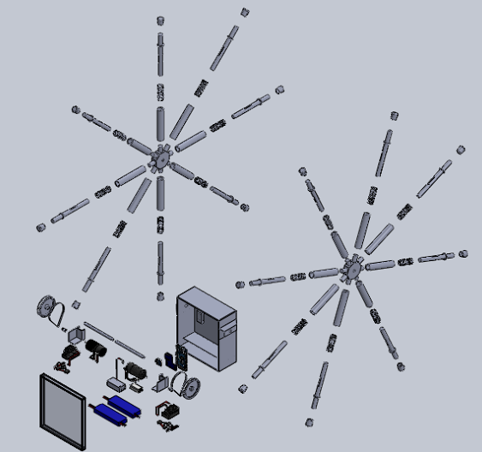

## Figure 4. Exploded View of Concept 1- Independently Actuated Legs

### 5.1.2 Functionality

The two motors would be connected to an electronic speed controller, which would control the speed of each wheel. A wireless transceiver module would be used in the robot and the wireless remote controller to send data to each other. Each motor will be controlled with its own joystick on the remote control. Moving the joystick up and down will get the wheels to move forward or backwards. By increasing the speed of one of the motors and decreasing the speed of the second this will allow for the robot to turn.

### 5.1.3 Specifications

This method must allow the robot to have a turning radius of 5 feet and a minimum speed of 5 mph.

### 5.1.4 Strengths

The method of differential drive has high mobility due to its pivot rotation and ability to turn in a small space. It also can make a turning radius of 5 ft. and a speed of 5 mph, as shown in the calculations in Appendix E. This design has an estimated cost of $1,209, which is $791 below the budget of $2,000.

### 5.1.5 Weaknesses

With each motor being on a different axel, it may be difficult to keep each wheel out of phase with each other to create the running effect. The additional spokes causes a slight increase in cost, but is still within the budget.

### 5.1.6 Conclusion

In this concept design, turning the RR2 would be managed by spinning the wheels are different speeds. It would satisfy the specified turning radius of 5 feet, and could even have a turning radius as small as 0 feet, if the wheels were spun in opposite directions.

## 5.2 Concept 2 – Steering Rack

### 5.2.1 Introduction

Concept 2 will use a steering rack and a differential in the torso to achieve the 5-foot turning radius. The basic idea of making something turn starts with the velocity traveled by one side is faster than that of the other side. One of the ways this can be achieved is by using a steering knuckle and a steering rack design and an open differential. The steering rack acts as a linear actuator that controls the angle in relation to the forward direction. The modern steering rack was created by Arthur Bishop in the 1970s. Open differentials allow each side of an axle to spin at different rates based on their traction. In order for the robot to achieve this concept of open differential, improving the design to RR1 to a one wheel drive setup would allow for the wheels to spin at different velocities.

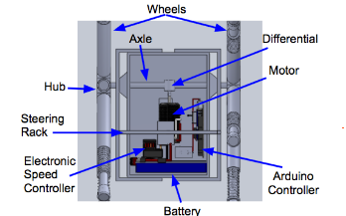

## Figure 5. Concept 2 - Steering Rack

### 5.2.2 Functionality

A steering rack is a mechanical device that uses a rack and pinion mechanism to turn a device. A rack is a rod that has gear teeth on it and it is connected to a spindle/ knuckle, which connects to the hubs. A pinion is gear that will turn on the gear teeth of the rack and move the rack left or right. The pinion will be turned using a motor and will be controlled by an Arduino. To allow the robot to turn while still connected to one axle, a differential will need to be used to allow one wheel to spin at a slower speed around a turn. The differential will be placed in the torso and will connect the two axle shafts of each wheel to the motor. For increased stability a tail will be added to the torso. The tail will increase stability of the torso by not allowing it to flip over.

### 5.2.3 Specifications

The knuckle must be able to turn the wheel to allow for a 5 foot turning radius.

### 5.2.4 Strengths

This design would allow for variable angle of turning radius. This concept is low in complexity and relative cost. It also meets all of the functional and performance specifications. This concept can make a turning radius of 5 feet and a speed of 5 mph, as shown in the calculations in Appendix E. This design has an estimated cost of $1,193, which is $807 below the budget of $2,000.

### 5.2.5 Weakness

The drive train would be weakened, now that both sides are not connected. The change in the drivetrain will affect the rotational pattern of the spokes and the energy loss as the spokes hit the ground. The spokes of the wheels will no longer make contact with the ground at a recurring pattern causing the robot to be unstable. This design would require a redesign of the torso to allow for turning and knuckle attachment. It would require additional electronic controls to be created for the linear actuator motor for steering. This design overall has increased complexity in design and manufacturing, due to the differential and the tail.

### 5.2.6 Conclusion

The steering knuckle will control the angle of one of the wheel causing the robot to turn. The wheel that is able to turn will no longer be attached to the drive axle and will be able to spin freely.

## 5.3 Concept 3 – Varying Wheel Radius

### 5.3.1 Introduction

In this concept linear stepper motors will be built into the legs of each wheel assembly. The linear stepper motors will allow the feet of the legs to contract and extend in order to vary the diameter of the wheels. In doing so this will allow the Roadrunner Robot 2 to turn accordingly. In Figure 6 shown below, the RR2 Has one wheel fully extended and the other fully contracted showing the variation in wheel radius.

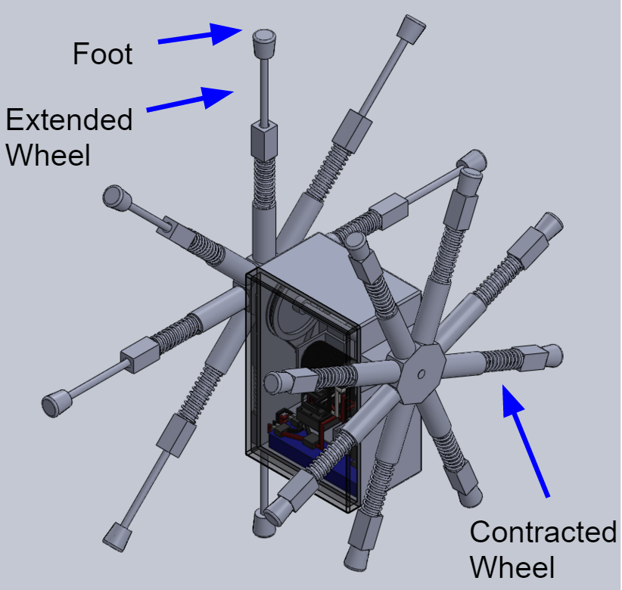

## Figure 6. Isometric View of Concept 3 – Varying Wheel Radius

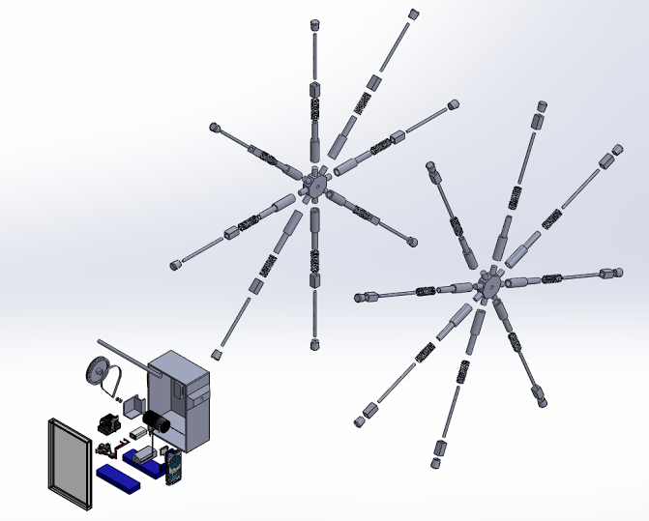

## Figure 7: Exploded View of Concept 3 – Varying Wheel Radius

### 5.3.2 Specifications

To achieve a turn radius of 5 feet the ratio of small wheel diameter to large wheel diameter must be less than 0.7. The larger wheel in this concept has roughly a diameter of 27 inches and the smaller wheel has a diameter of 18.4 inches. These dimensions allow the RR2 to obtain a turning radius of approximately 4.7 feet. The RR2 will use the same motor as in the other concepts and will be able to achieve a speed of 5 miles per hour.

### 5.3.3 Strengths

Linear stepper motors are very precise and accurate in controlling position of the threaded shaft. They require practically no maintenance. The design also utilizes the energy efficient concept of the rimless wheel. It will allow the RR2 to achieve its specified turning radius. The stepper motors would be easily replaced if needed. This design concept can make a turning radius of 5 feet and a speed of 5 miles per hour, as shown in the calculations in Appendix E.1 and E.2. This design has an estimated cost of $1,390, which is $610 below the budget of $2,000.

### 5.3.4 Weakness

The shaft of the motor will have to move freely in and out of the leg when the wheel extends and contracts. This limits the minimum leg size, which affects the turning radius of the RR2. The motor will have to withstand the weight of the RR2 and also the impact forces it is exposed to while the legs “run” when the wheels turn. Another weakness of this concept is that the stepper motors have to be wired to a controller. So the wires don’t tangle the controller will have to be mounted to the hub and rotate with the leg.

### 5.3.5 Conclusion

Since the linear stepper motors can vary the diameter of the wheels within the desired range to achieve a turn radius of 5 feet, this concept is sufficient for the purpose of the RR2.

## 5.4 Final Concept Selection Method

Stuart Pugh invented the Pugh chart. This decision-matrix is utilized in choosing the best design by ranking multiple options in a set [3]. Criteria for select components of the robot are rated on a scale from 1-5, 5 being the most important and 1 being the least important. A Pugh Chart was done for selection on cost, speed, manufacturability, and ability to meet the turning radius. This method for selecting the best concept aided in comparing the best options for the robot within the desired specifications stated above. Stated below is the selection of the final design for the robot. Although the highest rank for each criteria may not be chosen, the best option was selected with consideration to the other components of the robot.

## Table 1. Pugh Chart

|  |  |  |  |  |
| --- | --- | --- | --- | --- |
|  | **Weight** | **Robot Design** | | |
| **Selection Criteria** | **1-5** | **Concept 1: Independently Actuated Legs** | **Concept 2: Steering Rack** | **Concept 3: Contracting Legs** |
| Cost | 5 | 3 | 3 | 2 |
| Speed | 4 | 3 | 3 | 3 |
| Manufacturability | 3 | 3 | 2 | 3 |
| Ability to meet turning radius | 5 | 5 | 3 | 5 |
| Total |  | 57 | 48 | 47 |

With a budget of $2000, it was important to consider the cost of each concept. Concept 1 was given a rank of 3, with an estimated cost of $1,195. Concept 2 was given a rank of 3, with an estimated cost of $1,193. Concept 3 was given a rank of 1, with an estimated cost of $1,390.

Speed calculated (Appendix E). All concepts were calculated to meet the 5 miles per hour speed requirement.

Manufacturability was rated based on ease of assembly. Concepts 1 and 3 were ranked a 3 for reasonable assembly and Concept 2 was ranked a 2 for a more difficult assembly.

The turning radius was calculated using (Appendix E). All concepts were calculated to meet the 5-foot turning radius. Concept 2 was ranked a 3 for ability to meet the 5-foot turning radius. Concepts 1 and 3 were ranked a 5 for ability to meet a turning radius smaller than 5 feet.

The rankings for each concept were multiplied by the weight of the criteria. The concept design chosen for the Roadrunner Robot 2 was Concept 1: Independently Actuated Legs. All criteria were met with the highest total in rankings.

# 6.0 Final Design

## 6.1 Key Features

The key features established in the final design of the RR2 include its operation and functionality, mechanical systems, electrical systems, control systems, and the software used. These key features will be further discussed in the following sections.

### 6.1.1 Operation and Functionality

Control of the robot will originate at the remote controller. The remote controller will use an Arduino Mega board to interpret programmed commands given by pressing the buttons on the remote control. The Arduino Mega will use an Xbee Shield with a Zigbee component to send the commands to the Xbee shield with an additional Zigbee component located on the RR2. The Xbee Shields with Zigbee component are used to send and receive signals from the two Arduino boards. They send the signals over a personal network, which is provided by the Zigbee Module. Once the commands given by the user are received by the RR2, the Arduino Mega will then convert the signal and set the desired speed of the motors. The Arduino Mega will use two electronic speed controllers to control the voltage applied to each motor, in doing so the robot will meet its desired speed and or turns.

### 6.1.2 Mechanical Components

The torso of the robot will house all the electrical components. Inside the torso, the motors will be mounted. Each motor will be connected to a gear on an axle for each wheel, using a belt and a sprocket on the motors. The Gears will be attached to the axle using a screw that is threaded into a slot in the axles.  Each axle will be held in place by two needle roller bearings. On the outside of the torso, the hubs will be attached to the axles. Each hub will have 10 legs attached to them.  Each leg will have a spring attached to the outer end of the leg.

The Roadrunner Robot 1 design had a few key issues and FOA Engineering recommended they be noted. The first issue was the belt that was used would slip on the gear under high force. For Roadrunner Robot 2, two belts will be used to reduce the stress caused on the belts. The second main issue the Roadrunner Robot 1 had was the hub would break at the connection of the legs. In order to solve this issue, the Roadrunner Robot 2 will have a hub made out of aluminum.

The legs of the robot are designed to reduce the energy lost by the impact made with the ground.  To improve the energy efficiency, springs were added to each of the legs.  Based on slot design of the legs, the maximum deflection of the spring allowed is 1 inch.  This led to the spring rate to be 15 pounds per inch. Based on what was available a spring of overall length of 2.5 inches and spring rate of 15 lbs/in was chosen.

A differential drive system will be used to add turning capabilities the robot. The differential drive system will allow each rimless wheel to turn independently of each other. Turning the wheels at different speed will force the robot to change directions towards the slower turning wheel. The greater the difference in speeds of each wheel, the smaller the turn radius would be.

### 6.1.3 Electrical Systems

#### 6.1.3.1 Introduction

The Roadrunner Robot 2 will house all of its electrical components in the torso of the robot, located in between the two wheels. The electronics will include but is not limited to: a motor, Arduino Mega Controller, Xbee Shield, Zigbee Module, batteries, and Electronic Speed Controller (ESC). The electronics will be used to send a command via remote control to the Arduino board to ultimately control the robot's speed and turning capabilities.

#### 6.1.3.2 Functional Requirements

Control of the robot will originate at the remote controller. The remote controller will use an Arduino Leonardo board to interpret programmed commands given by pressing the buttons on the remote control. The Arduino Leonardo will use an Xbee Shield with a Zigbee component to send the commands to the Xbee shield with an additional Zigbee component located on the RR2. The Xbee Shields with Zigbee component are used to send and receive signals from the two Arduino boards. They send the signals over a personal network, which is provided by the Zigbee Module. Once the commands given by the user are received by the RR2, the Arduino Mega will then convert the signal and set the desired speed of the motors. The Arduino Mega will use two electronic speed controllers to control the voltage applied to each motor, in doing so the robot will meet its desired speed and or turns.

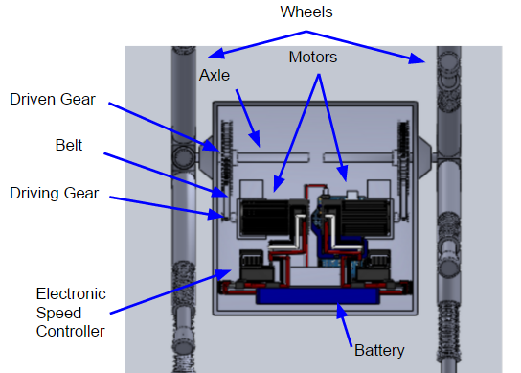

## Figure 8. Electrical System

### 6.1.4 Controls Systems

The remote control is a wireless gamepad that is based on Arduino. The remote control has an Arduino Leonardo, which the Xbee module is connected to, as shown in the figure below. The Arduino Leonardo acts as a boot loader and holds the data and software for the Xbee. The remote control has 2 joysticks, one reset button and 16 programmable buttons. The button controls are discussed in the Theory of Operations Manual (Appendix A). It needs an input voltage of 7-12V and is powered by 3 “AAA” batteries.

### 6.1.5 Software

The program that the robot will be operated by will be as shown, in the software diagram below. The robot will not move until a command is executed on the remote control. If the command is not received the robot will not move and the user will select a command again. Once the robot receives the command, it is to move forward until an obstacle is returned or needs to turn.

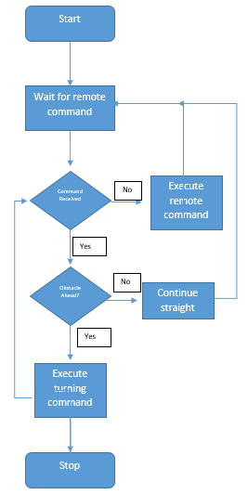

## Figure 9. Software Diagram

## 6.2 Estimated Performance

### 6.2.1 Form Features

To determine the number of legs that would result in the most efficient robot, analysis was done to find the energy lost after one step. Equation 5 and Equation 6 (Appendix E) were used to find the Mass Moment of Inertia.  Assuming the radius of each leg to be 0.375 inches, density of 0.0376 lbm/in3, and 10 inches long. The values for moment of inertia can be found in Table 11 (Appendix E). Using the mass moment of inertia of different number of spoke and assuming an initial velocity before each step, Equation 7 (Appendix E) was used to find the angular velocity after each step. The values were shown in Table 12 (Appendix E), which also shows the rotational energy before and after the step using Equation 8 (Appendix E).

Increasing the number of legs, decreases the energy lost, but at the cost of adding more material and weight. Table 2 (Appendix E) displays the percent of energy that remains after each step.  It also shows the ratio of the energy remaining to the mass of the legs.  This ratio is important because the higher the ratio of energy remaining to the mass, the more cost effective the design will be. This is also illustrated graphically in Figure 20 (Appendix E).

### 6.2.2 Estimated Life

Two 3s LiPo batteries were used to power the motors to the robot. By dividing the capacity of the batteries with the constant current drawn from them the time the batteries will last can be calculated. Each charge of the batteries will last 25 minutes (Equation 9, Appendix E).

## 6.3 Material Selection and Justification

The material section on the RR2 was selected on availability, cost, effectiveness and performance. The hubs were chosen to be made out of aluminum due to its shape and its ability to be machined. The driveshaft was chosen to be made out of steel due to the high bending and shear stresses. The legs and torso were constructed out of ABS plastic, due to the availability to be 3D printed and cost effectiveness.

## 6.4 Assemblies and Parts

The RR2 has 9 fabricated parts. All design drawings for these 9 parts and the 7 assemblies can be found in Appendix D. There are 2 motor shelves are adjustable shelves that hold the 2 motors inside of the box. The box is made up of 3 parts: the back wall, sides, and lid. The back wall is detachable from the sides for easy assembly and the lid is able to slide on at the front of the box. There are 2 axles, one for each rimless wheel so they are able to move independently. The legs consist of 2 pieces: the tube and rod. This design allows for the use of a compression spring in each leg. There are 2 hubs, each with 10 pegs that connect to the legs.

Assembling the RR2 can be broken down into several smaller subassemblies. The hubs and legs have their own subassemblies before assembling together to form the rimless wheel. The motor, microcontroller, data acquisition, and body have their own subassemblies before assembling together to form the torso of the robot. The top assembly can be seen below.

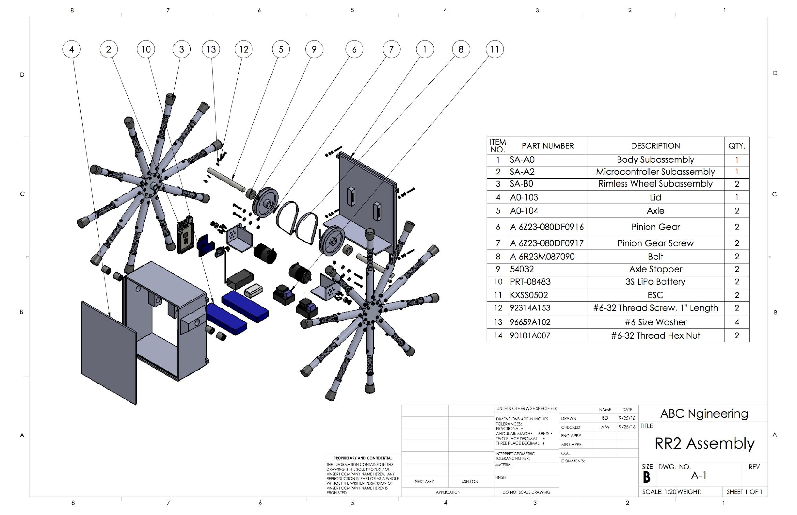

## Figure 10. Roadrunner Robot 2 - Top Assembly

# 7.0 Prototype Fabrication

## 7.1 Fabrication Methods

### 7.1.1 Machine Shop

The hubs, pegs, and axles were fabricated at the UTSA Machine Shop and were created based off of the design drawings created using SolidWorks. A mill and lathe were used to create these parts.

### 7.1.2 3D Printing

The parts for the legs and torso were fabricated using a 3D printer at UTSA and were created based off of the designs created using SolidWorks. The 3D printer prints according to the Stereo Lithography file from SolidWorks. The completed part is then run through a chemical bath to remove any supports.

## 7.2 Prototype Fabrication Drawings

All part and assembly drawings can be seen in Appendix D. These parts were designed using Computer-Aided Design software SolidWorks. Each part drawing consists of dimensions, tolerances, and any necessary geometric characteristics that need to be considered during fabrication. For any metal parts, a slip fit is needed. These parts are sized 0.002” apart. 3D printed parts are sized 0.02”-0.03” apart depending on the assembly. Each assembly drawing consists of a Bill of Materials table referencing each part name, part number, and quantity of each part that is included in this assembly.

## 7.3 Bill of Materials

## Table 2. Bill of Materials

|  |  |  |  |  |  |  |
| --- | --- | --- | --- | --- | --- | --- |
| **Item No.** | **Component** | **Description/Identification No.** | **Vendor** | **Qty.** | **Price/Unit** | **Cost** |
| 1 | Remote Control | SKU: DFR0182 | Robot Shop | 1 | $59.90 | - |
| 2 | Arduino Mega 2560 | SKU: 20-011-910 | Amazon | 2 | $18.90 | $37.80 |
| 3 | Arduino Zigbee Shield | SKU:20-011-902 | Sainsmart | 2 | $9.79 | $19.58 |
| 4 | Arduino Zigbee Module | WRL: 11215 | SparkFun | 2 | $24.95 | $49.90 |
| 5 | Motor and Electronic Speed Control | KXSS0501 | Horizon Hobby | 2 | $74.99 | $149.98 |
| 6 | #6-32 Thread, 1" Length | 92314A153 (1 pack of 50) | McMaster-Carr | 1 | $9.21 | $9.21 |
| 7 | #6 Screw Size Washer | 96659A102 (1 pack of 100) | McMaster-Carr | 1 | $3.44 | $3.44 |
| 8 | #6-32 Thread Hex Nut | 90101A007 (1 pack of 100) | McMaster-Carr | 1 | $7.87 | $7.87 |
| 9 | #4-40 Thread, 1" Length | 92314A115 (1 pack of 50) | McMaster-Carr | 1 | $8.12 | $8.12 |
| 10 | #4 Screw Size Nylon Bushing | 94639A664 (1 pack of 100) | McMaster-Carr | 1 | $10.09 | $10.09 |
| 11 | #4 Screw Size Washer | 96659A101 (1 pack of 100) | McMaster-Carr | 1 | $2.96 | $2.96 |
| 12 | #4-40 Thread Hex Nut | 90101A004 (1 pack of 50) | McMaster-Carr | 1 | $4.12 | $4.12 |
| 13 | Spring | 9657K421 (4 packs of 6 springs) | McMaster-Carr | 4 | $7.08 | $28.32 |
| 14 | Needle Roller Bearing | SCE812 | New Egg | 4 | $4.86 | $19.44 |
| 15 | Pinion Gear | A 6Z23-080DF0916 | SDP/SI | 2 | $10.19 | $20.38 |
| 16 | Spur Gear | A 6A23-010DF0904 | SDP/SI | 2 | $13.55 | $27.10 |
| 17 | Belts | A 6R23M087090 | SDP/SI | 2 | $8.04 | $16.08 |
| 18 | 3s LiPo Battery | EFLB30003S30 | Horizon Hobby | 2 | $39.99 | $79.98 |
| 19 | Battery Charger | EFLC3016 | Horizon Hobby | 1 | $31.49 | $31.49 |
| 20 | EC3 Device Charge Lead | EFLAEC312 | Horizon Hobby | 1 | $6.99 | $6.99 |
| 21 | 9V Battery | 19350 | Amazon | 1 | $21.99 | $21.99 |
| 22 | 9V Adapter | 19383 | Local | 1 | $3.95 | $3.95 |
| 23 | Hub | 6061-T6 Aluminum Disc | Local | 2 | $13.88 | $27.76 |
| 24 | Pegs | 6061-T6 Aluminum Disc | Local | 1 | $9.61 | $9.61 |
| 25 | Rubber Leg Tips | SKU: 762 099 | Local | 20 | $0.46 | $9.20 |
| 26 | Axle | 1/2" plain steel round rod 36" long | Local | 1 | $5.77 | $5.77 |
| 27 | Velcro | 3 ft | Local | 3 | $2.97 | $8.91 |
| 29 | Jumper Wire Kit |  | Local | 1 | $8.95 | $8.95 |
| 28 | IMU | SEN-10724 | Digi Key | 1 | $49.95 | $49.95 |
| 30 | Sparkfun Open Log | DEV-13712 | SparkFun | 1 | $14.95 | $14.95 |
| 31 | Wheel encoder Kit | ROB-12629 | SparkFun | 2 | $12.95 | $25.90 |
| 32 | MicroSD Card with Adapter- 8GB | COM-11609 | SparkFun | 1 | $13.95 | $13.95 |
| 33 | Arduino Pro 328 - 3.3V/8MHz | DEV-10914 | SparkFun | 1 | $9.95 | $9.95 |
| 34 | Polymer Lithium Ion Battery - 2000mAh | PRT-08483 | SparkFun | 1 | $12.95 | $12.95 |
| 35 | FTDI Basic Breakout- 3.3 V | DEV-09873 ROHS | SparkFun | 1 | $14.95 | $14.95 |
| 36 | Axle Stopper | 54032 | Amazon | 1 | $8.27 | $13.95 |
|  |  |  |  | **Total:** | | **$785.54** |
|  |  |  |  | **Total Budget:** | | **$2,000.00** |
|  |  |  |  | **Amount Left:** | | **$1,214.46** |

# 8.0 Prototype Tests

## 8.1 Test Plan Summary

The main areas of focus for testing on the RR2 are going to be its performance specifications. Although there will be other tests conducted, the specifications of turning radius and speed will be the team's main concern. Other specifications that will be tested include but are not limited to; weight, dimensions, power supply, electronics configuration, and the controls.

## Table 3: Compliance Matrix

|  |  |  |  |  |
| --- | --- | --- | --- | --- |
| **Item Number** | **Feature Tested** | **Specification** | **Testing Procedure** | **Compliance Status (Pass/Fail)** |
| 1 | Dimensions, radius, width | 1.2.1  1.2.1.1  1.2.1.2 | Test T-1 | Pass |
| 2 | Weight | 1.2.2 | Test T-2 | Pass |
| 3 | Number of legs | 1.2.3 | Visual | Pass |
| 4 | Material | 1.2.4 | Visual | Pass |
| 5 | Soldering | 1.2.5 | Visual | Pass |
| 6 | Speed | 2.1  2.7 | Test T-3 | Pass |
| 7 | Microcontroller | 2.2 | Visual | Pass |
| 8 | Microcontroller | 2.2.1 | Test T-4 | Pass |
| 9 | Microcontroller | 2.2.2 | Test T-5 | Pass |
| 10 | Remote Control | 2.3 | Test T-6 | Pass |
| 11 | Power Supply | 2.4 | Visual | Pass |
| 12 | Spring | 2.5 | Visual | Pass |
| 13 | Turn Radius | 2.6 | Test T-7 | Pass |

## 8.2 Test Setup

The setup and material of the test that were performed on RR2 are essential to the data collection and accuracy of the results. Testing was conducted inside the Main Building of the UTSA Main Campus. It is imperative to test indoors in order to have a controlled environment and to avoid interference with the microcontroller. The floor of the main building is 12”x12” tile and they are grouted 8 millimeter. This allows for a smooth and nearly seamless test floor. The test facility will have to be a minimum of 100 feet long in order to meet one of the test requirements. Painter’s tape, a stopwatch and a measuring tape will all be required to set up the test facility.

A computer is needed for the encoder, microcontroller, and to record data. The encoder and IMU have an SD Card (Secure Digital Card) to store the collected data, which will be viewed on the computer. Components of the microcontroller require coding on the Arduino software.

## 8.3 Test Results

## Table 4. Test T-1 Data

|  |  |
| --- | --- |
| **Dimension** | **Measurement** |
| Radius of rimless wheel | 10 in |
| Width of robot | 1 ft, 0.5 in |
| **Pass/Fail** | Pass |

## 

## Table 5. Test T-2 Data

|  |  |
| --- | --- |
| **Dimension** | **Measurement** |
| Weight of RR2 | 13.2 lbs |
| **Pass/Fail** | Pass |

## 

## Table 6. Test T-3 Data

|  |  |
| --- | --- |
| **Test Run** | **Measurement** |
| Test Run 1 | 4.6 mph |
| Test Run 2 | 3.8 mph |
| Test Run 3 | 5.6 mph |
| Test Run 4 | 6.1 mph |
| Test Run 5 | 5.9 mph |
| **Pass/Fail** | Pass |

## Table 7. Test T-4 Data

|  |  |
| --- | --- |
| **Test Run** | **Memory** |
| Test Run 1 | 9.7 kB |
| **Pass/Fail** | Pass |

## Table 8. Test T-5 Data

|  |  |
| --- | --- |
| **Test Run** | **Measurement** |
| Test Run 1 | 8.4 V |
| **Pass/Fail** | Pass |

## Table 9. Test T-6 Data

|  |  |
| --- | --- |
| **Movement** | **Pass/Fail** |
| Stop | Pass |
| Increase Speed | Pass |
| Decrease Speed | Pass |
| Turn | Pass |
| **Pass/Fail** | Pass |

## Table 10. Test T-7 Data

|  |  |
| --- | --- |
| **Test Run** | **Measurement** |
| Test Run 1 | 1.6 ft |
| Test Run 2 | 2.3 ft |
| Test Run 3 | 2.1 ft |
| **Pass/Fail** | Pass |

# 9.0 Project Management

## 9.1 Schedule

Senior Design 1 and II were planned using a Gantt chart on Microsoft Projects. Senior Design 1 consisted of 4 assignments, 9 work packages, a midterm presentation, a final presentation, project binder, and a final project report.

Assignment 1 consisted of identifying and summarizing 25 unique senior design projects. After summaries were made, two projects were chosen and modified to fit the senior design curriculum at UTSA. Then the student was required to write a unique project proposal. Assignment 2 required the preliminary teams to design, analyze, build, and test a rubber band powered car. The car was to be made of straws, Styrofoam, Popsicle sticks and a rubber band. Once the car was complete the group was to write a technical report about the project. Assignment 3 required each student to create a Gantt chart for all of their classes for the spring 2016 semester. Assignment 4 required each student to describe the expectations for the members of their permanent senior design group.

Work Package 1 was about team formation. Each team identified a team name and logo, goals, criteria for member selection, and a signed statement committing each member to the team goals. Work Package 2 required each team to identify a design problem. A purpose and objective was to be presented along with preliminary specifications and functional requirements. The team was required to identify the project mentor and mentor’s qualifications. 25 summarized patents were relating to the project were required in the appendices. Work Package 3 required each team to define detailed project specifications and functional requirements. The team was to select three potential solutions to the problem and present a selected concept with backing selection methodologies. Work Package 4 required each team to provide detailed analyses of the selected design concept. Work Package 5 required each team to provide fabrications plans for their project and an estimated cost. Work Package 6 required each team to provide test plans to demonstrate that the project specifications were achieved. Work Package 7 required each team to provide a detailed Gantt chart of Senior Design I and II summarizing all assignments. Work Package 8 required each team to provide a detailed outline of the final project report along with profile sheets for each section. Work package 9 required each team to present detailed project labor and material cost.

The midterm presentation summarized everything in Senior Design I from the beginning through Work Package 6. The goal was to present the team's project, concept designs, selected concept, and supporting analyses and selection methodologies. The final presentation summarized current status of design project during Senior Design I and summer plans to maintain on schedule to meet deadlines in Senior Design II. The final project poster required each team to display a standalone poster that describes the team’s project to the viewer.

During summer break, the team plans to finalize design specifications and dimensions, and to start preparing drawings for Senior Design II.

Senior Design II will consist of the build and test aspects of senior design. The schedule is based off of the main parts of Senior Design II, which include a Detailed Design Drawing Package with a Software/Electronic Plan, a fully developed Test Plan, Fabrication, Testing, Critical Design Reviews, and reports.

The Detailed Design Drawing Package will include engineering drawings of all parts of the project with dimensions, tolerances, material selection, and material finish. The Software/Electrical package will include the analyses of the software used for the project.

The Test Plan will include details of the tests required for the project, descriptions for the tests, the environments in which the tests will occur, and analyses and reporting.

The Fabrication Plan will include all materials required for purchase for the project and assembly of the project in order to start testing. Once the project is complete testing can be started to ensure the project meets its required specifications.

The Critical Design Reviews, the final poster, and final binder report will present and showcase the team's work for Senior Design I and II.

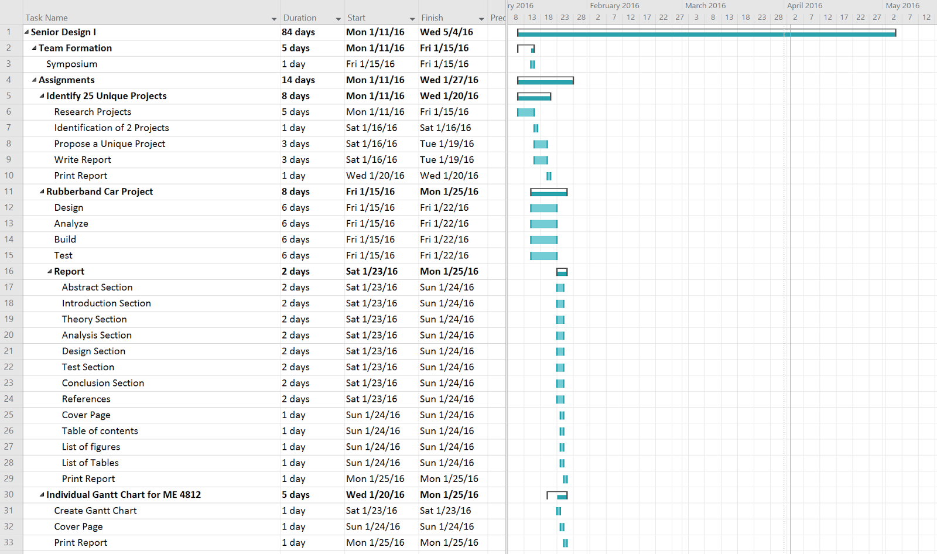

## Figure 11. Work Breakdown Schedule 1

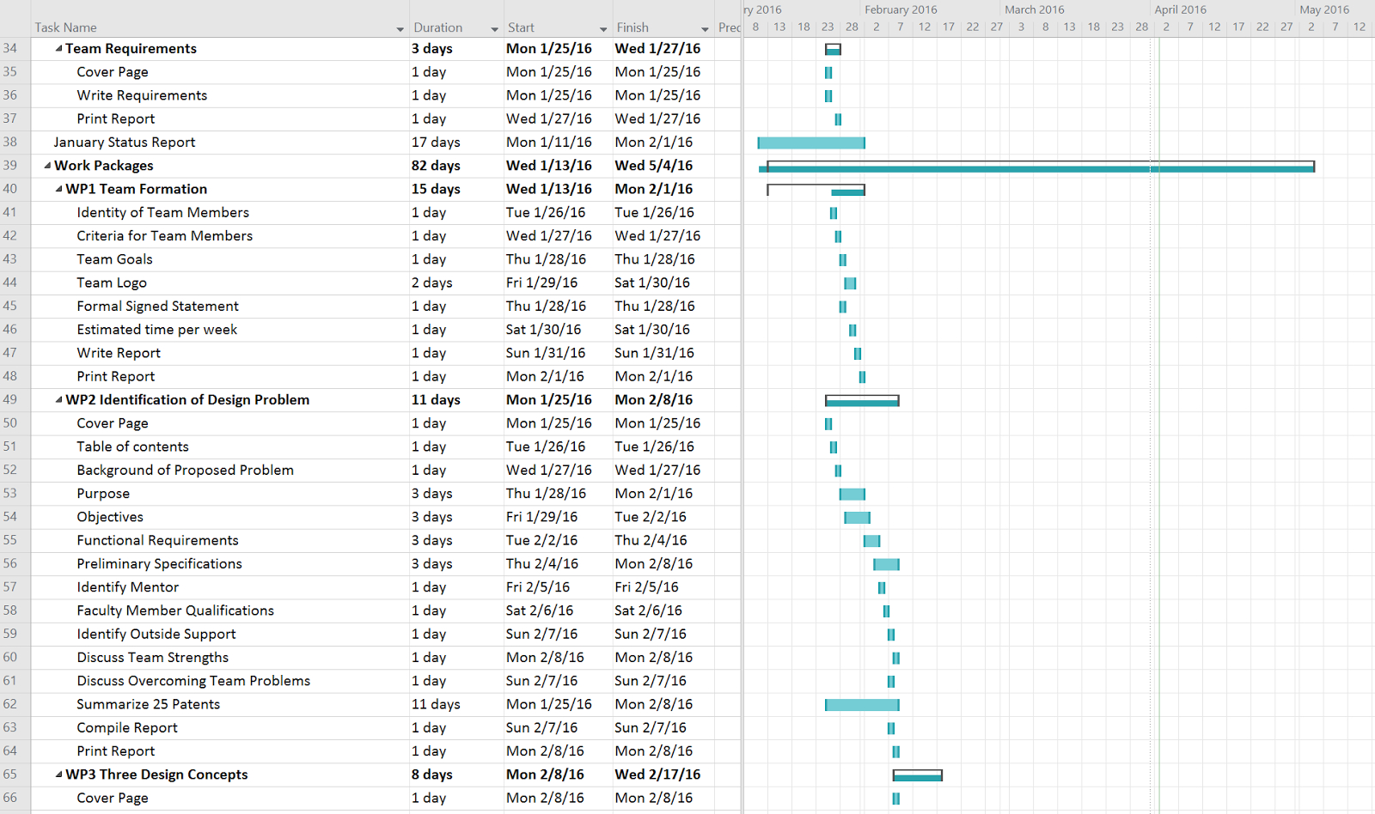

## Figure 12. Work Breakdown Schedule 2

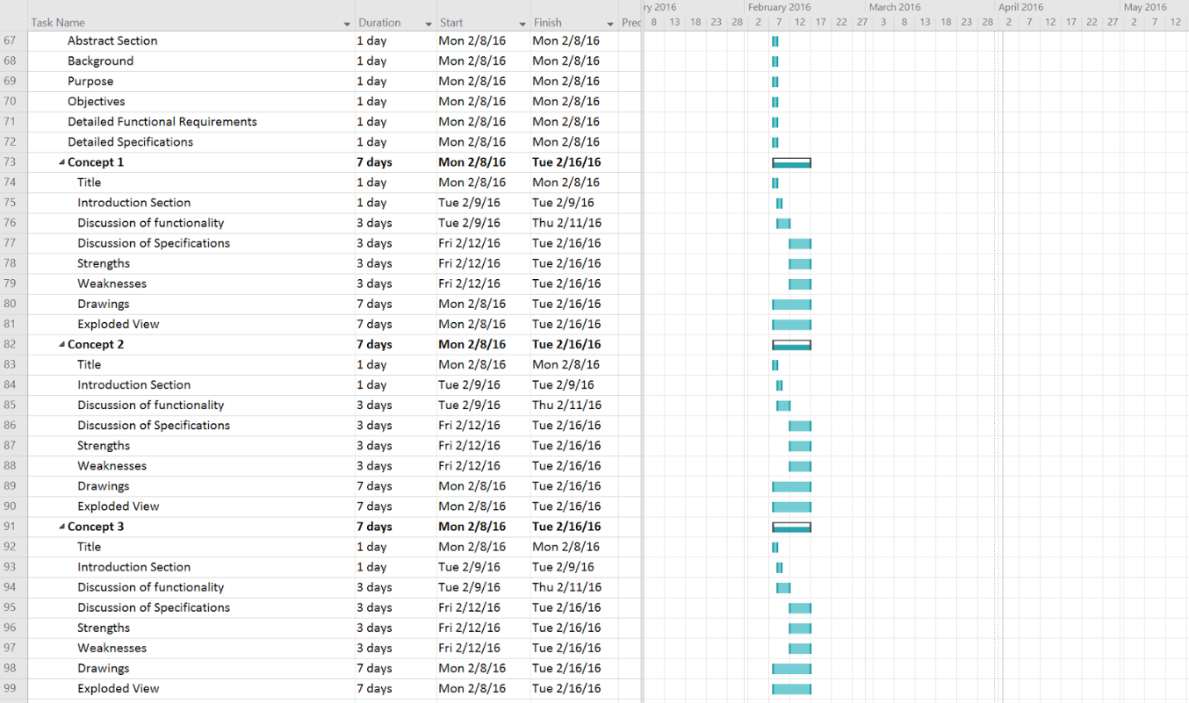

## Figure 13. Work Breakdown Schedule 3

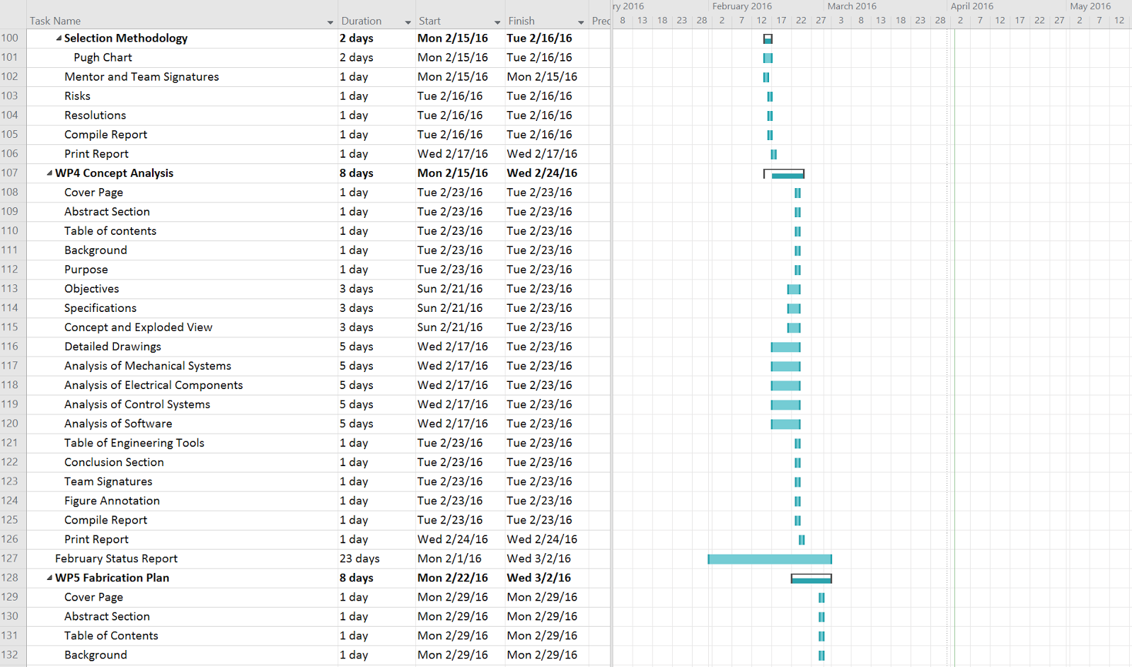

## Figure 14. Work Breakdown Schedule 4

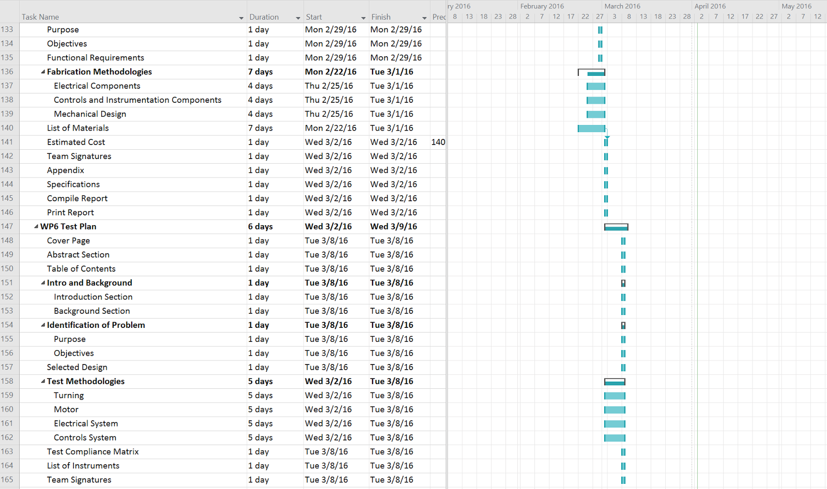

## Figure 15. Work Breakdown Schedule 5

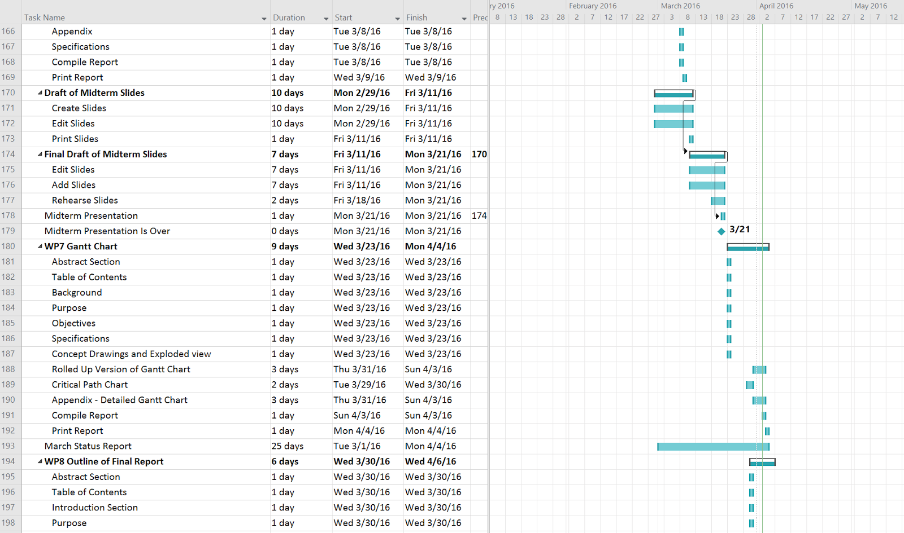

## Figure 16. Work Breakdown Schedule 6

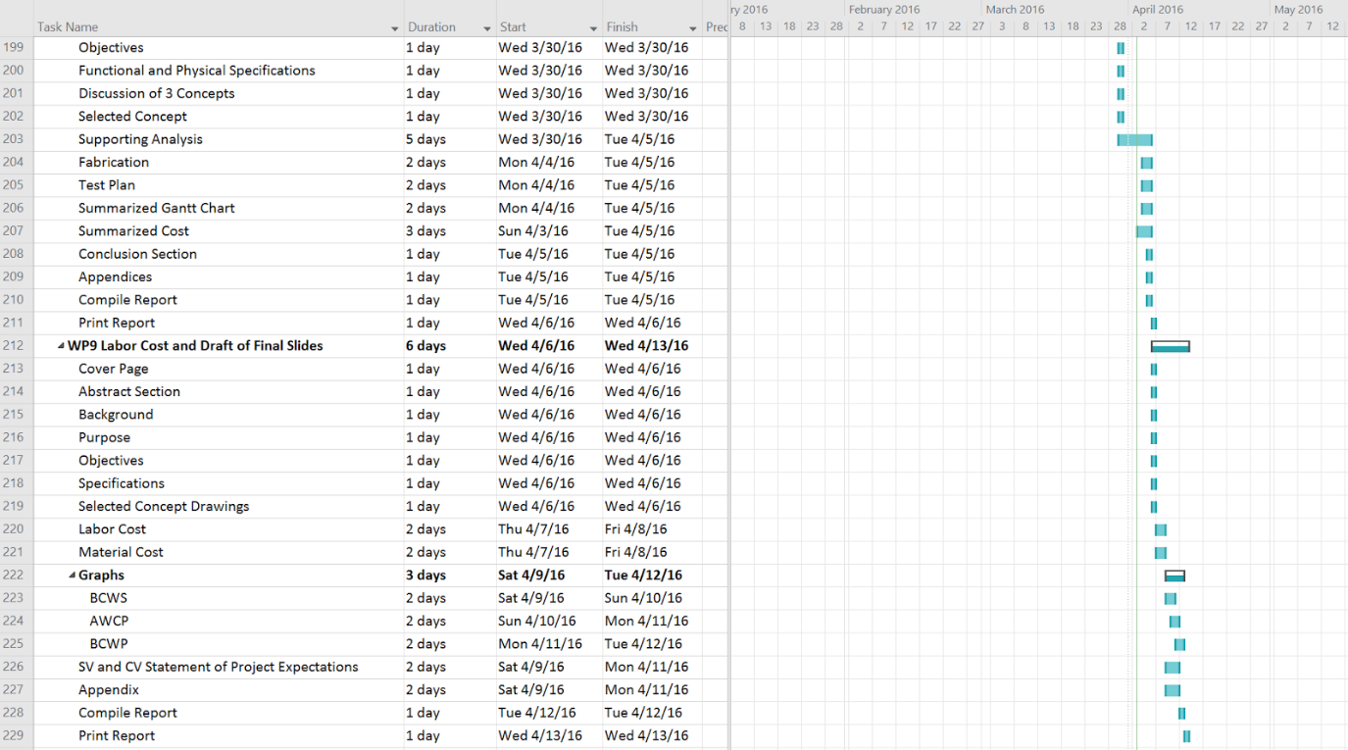

## Figure 17. Work Breakdown Schedule 7

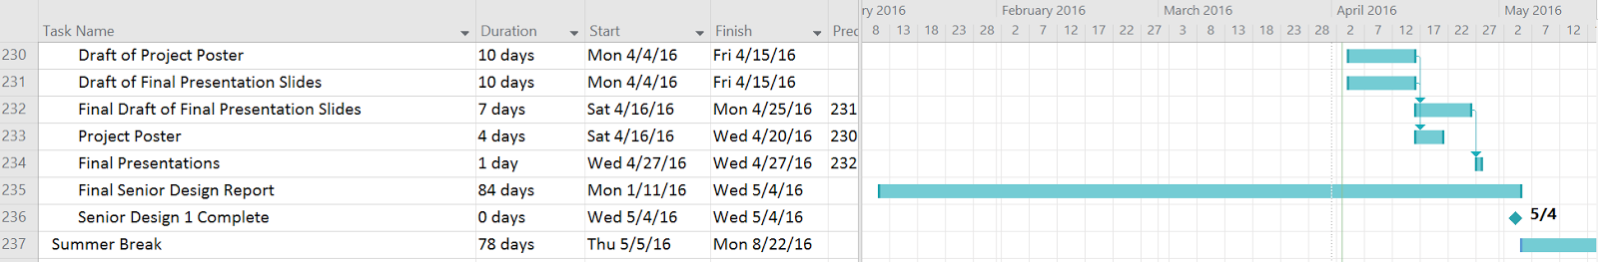

## Figure 18. Work Breakdown Schedule 8

## 9.2 Financial Performance

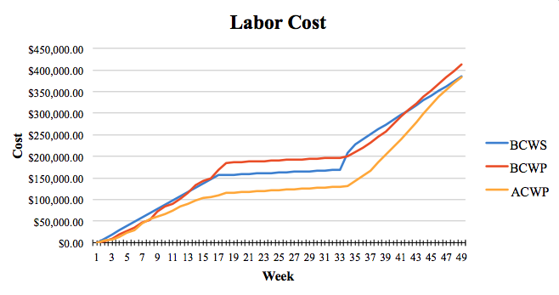

## Figure 19. Project Labor Cost

The BCWS was calculated by adding the cost of every task scheduled and was estimated to be $384,952.48. The BCWP was calculated by adding the cost of every planned task from week 1 to week 48 and was estimated to be $412,745.20. The ACWP was calculated by adding the cost for the actual time spent on each task from the week 1 to week 48 and was estimated to be $383,855.00. The project schedule variance (SV) [Equation 10, Appendix E] was estimated to be $27,792.72. This positive variance means that the project is ahead of schedule. The project cost variance (CV) [Equation 11, Appendix E] was estimated to be $28,890.59. This positive variance means that the project is under budget. Other performance metrics to keep track of the project’s progress include the schedule performance index (SPI), the cost performance index (CPI), and the cost schedule index (CSI). The SPI (Equation 12, Appendix E) was estimated to be 1.07. The SPI being greater than 1 means that the project is ahead of schedule. The CPI (Equation 13, Appendix E) was estimated to be 1.38. The CPI being greater than 1 means that the project is under budget. The CSI (Equation 14, Appendix E) was estimated to be 1.15. This number being close to 1 means that the project is able to recover to stay on track.

The total cost for all materials was $785.54. With a $2000 budget, there is $1,214.46 left over.

# 10.0 Project Conclusions

In testing the RR2 was able to achieve a minimum speed of 5 miles per hour while traveling straight. The RR2 was able to complete a 5-foot turning radius and could be controlled from a distance of 50 feet. ABC Ngineering worked under the mentorship of Dr. Pranav Bhounsule to design, analyze, build, and test the RR2 to further research for the Robotics and Motions Laboratory at The University of Texas at San Antonio.

# 

# References

[1] Coleman, Michael J. "Dynamics And Stability Of A Rimless Spoked Wheel: A Simple 2D

System With Impacts." *Dynamical Systems: An International Journal* 25.2 (2010):

215-238. *Computer Source*. Web.

[2] Lucas, G.W. "A Tutorial and Elementary Trajectory Model for the Differential Steering

System of Robot Wheel Actuators." *A Tutorial and Elementary Trajectory Model for The*

*Differential Steering System*. 2001. Web.

[3] "Pugh Matrix Step by Step." *Decision-making-confidence.com*. Decision Making

Confidence, n.d. Web.

[4] Pyle, Rod. "Rough Road Ahead: Rocky Mars Terrain Challenges Curiosity Rover."

*Space.com*. N.p., 25 July 2014. Web.

[5] Shankar, Krishna, and Joel W. Burdock. *Motion Planning and Control for a Tethered,*

*Rimless Wheel Differential Drive Vehicle*. Rep. N.p.: California Institute of Technology,

2013. Print.

[6] Surya Nurzaman. "Bio-Inspired Motor Control." *Lecture 2: Legged Locomotion*. ETH

Zurich, 25 Sept. 2012. Web.

[7] "Tekin - T8 GEN2 1/8 Brushless Motors." Tekin - T8 GEN2 1/8 Brushless Motors. N.p., n.d.

Web.

[8] Xiao, John, Siegwart, and Nourbakhsh. *Robot Locomotion and Kinematics*. Rep. N.p.: n.p.,

2005. Print.

# Appendix A – Theory of Operations Manual

# 1.0 Product Description

## 1.1 Importance of Product

The goal of the Roadrunner Robot 2 (Figure 1), as seen below, is to further the research of rimless wheels, before it can be used towards possible applications such as a rover on land, lunar, or Martian surfaces. The RR2 is a rimless wheeled robot that is designed to achieve a speed of 5 miles per hour and a turning radius of 5 feet.

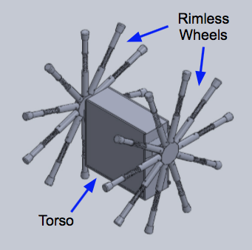

## Figure 1. The Roadrunner Robot 2 - Isometric View

## 1.2 Function

The rimless wheel design is based off of a traditional rimmed wheel and the legged locomotion. Rimmed wheeled locomotion is the preferred method of most transportation because of its simplicity, efficiency and reliability. Wheels reduce the amount of friction caused when moving an object across a surface, which allows the wheel to move using less energy.  Legged locomotion combines the biology of a human walking with robotics and is the interaction between the legs of the system and the environment [1]. When humans walk they show great control of movement, dexterity and stability [2]. However, it is still unknown exactly how humans accomplish this, which is why the study of legged locomotion is so imperative. Legged locomotion is used for movement over rough or uneven terrain, which is quite difficult for traditional rigid robots. The rimless, spoked wheel combines the speed of a traditional rimmed wheel with the mobility of legged locomotion. The rimless wheel has a hub, which is surrounded by spokes with a fixed angle between them. By being able to control the dynamic motion of the robot, this could lead to a significant decrease in the energy required by the system, which would increase the rimless wheel’s efficiency [3].

## 1.3 Functional and Physical Specifications

The RR2 is able achieve a speed of 5 miles per hour and a turning radius of 5 feet and can be controlled by using the remote control up to a distance of 50 feet. The remote control has sufficient capabilities to stop the motor, increase motor speed, decrease motor speed, and control turning operations. The microcontroller will receive commands from the robot operator through Zigbee Mesh network, which uses IEEE standard 802.15.4. It will output speed and control commands to the motors through the ESC (electronic speed controller). The robot does not exceed 20 pounds, the radius of the wheel is 10” and the width is 1 foot.

# 2.0 Theory of Operation

## 2.1 Mechanical

The Lithium polymer batteries contain potential energy that is used to power the motors. The motors transfer the Potential energy into kinetic energy and turn a shaft. The shaft spins the drivetrain, hubs and legs to allow the RR2 to move. The motion of the RR2 will depend on which direction each motor is spun and at what rate it is spun. As each leg makes contact with the ground, some of that energy is lost which decreases the amount of possible motion. Each leg of the Road Runner Robot 2 will be assembled with a spring attached to the lower half of each leg. With the addition of a spring, some of energy that was previously lost will be stored in the form of potential energy as the weight of the robot compresses the spring. As the leg is rotated and the spring begins to decompress, the energy will be released as kinetic energy and push the robot forward. This design will increase the energy efficiency of the robot.

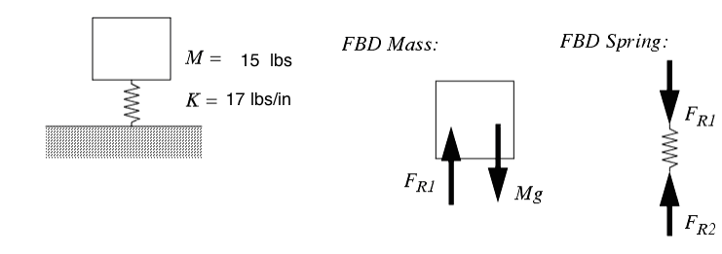

## Figure 2. Mass Spring Free Body Diagram [6]

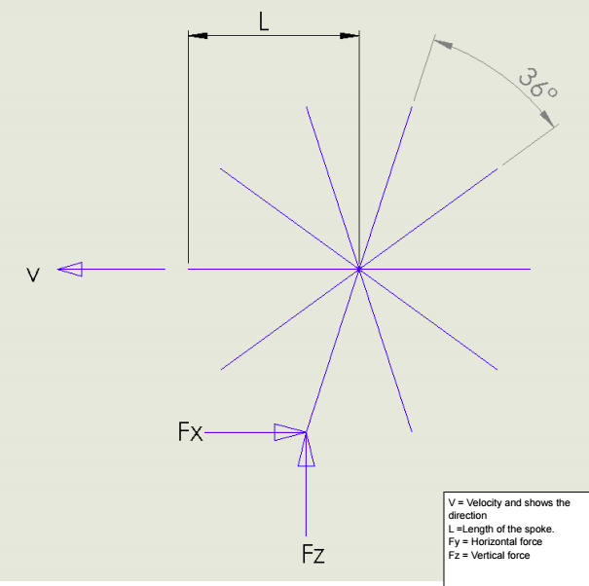

## Figure 3. Rimless Wheel Free Body Diagram

## 2.2 Electronics

### 2.2.1 Introduction

The RR2 is driven by two Kinexsis 4000 Kv brushless motors. Each motor is controlled by a Kinexsis electronic speed controller (ESC), which receives input from the Arduino Mega through the PWM pins. The ESCs use battery eliminator circuits (BECs) to supply the motors power up to 6V at a current of 3A. Figure 4, illustrates the configuration of all electronic components. Each component will be discussed in the following sections.

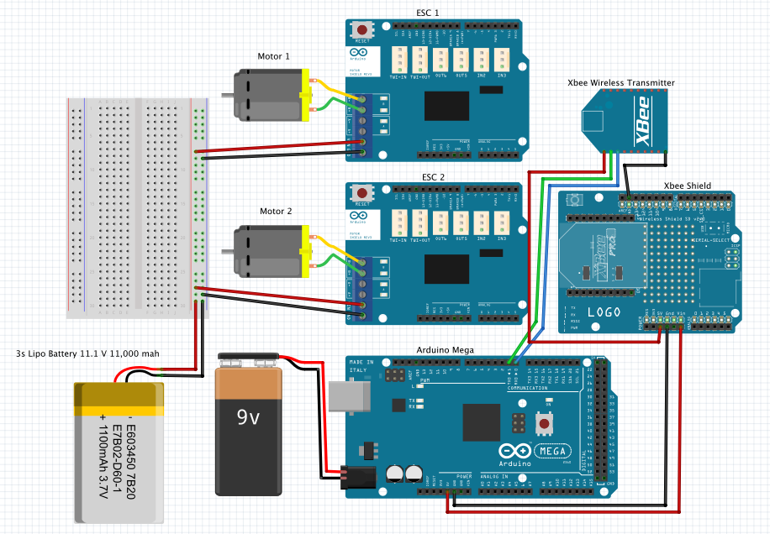

## Figure 4. Circuit Diagram of Electrical System

### 2.2.2 Motors

Two Kinexsis 1/10 scale 4000 Kv motors, as shown in Figure 5, below, will drive the robot. Figure 6 shows the drive shaft and is what will transfer power from the motor through the gears to the rimless wheels.

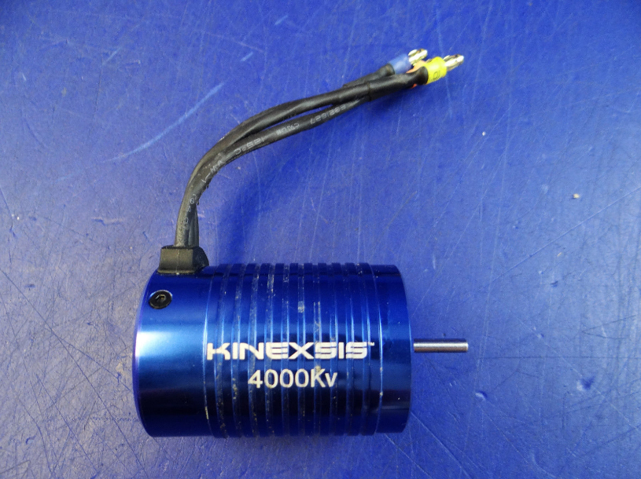

## Figure 5. Kinexis 4000 Kv Motor [7]

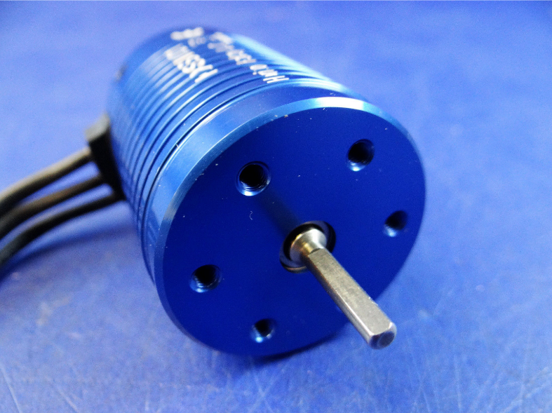

## Figure 6. Motor Drive Shaft [7]

On the opposite side of the motor there are three connecting wires to connect the motor to the corresponding ESCs. Figure 7 shows wires A, B, and C, which will connect to ports A, B, and C on the ESCs.

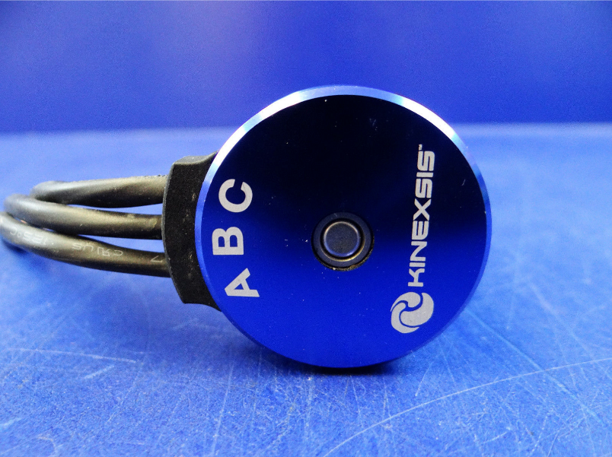

## Figure 7. Motor Connecting Wires [7]

### 2.2.3 Electronic Speed Controllers (ESCs)

The power provided to the motors will be controlled by the electronic speed controllers (ESCs). The Motors and ESCs will use up to 11.1 volts and it will be supplied to the ESCs by two separate 3s LiPo batteries. Figure 8 below shows an ESC. The ESCs vary the power to the motor by varying the switching rate of a network of field effect transistors, or FETs. An Arduino Mega will be used to send the user’s controls to the ESCs and in turn the motors. On each ESC the three wires color-coded blue, yellow, and orange are wires A, B, and C that connect the motors to the ESCs. On the same side there is a red and black wire, which will connect to the Arduino board via a PWM pin to send commands to the ESCs. On the opposite side there are two wires, a red and a black, which will connect to a 3s LiPo battery’s positive and negative connection terminals.

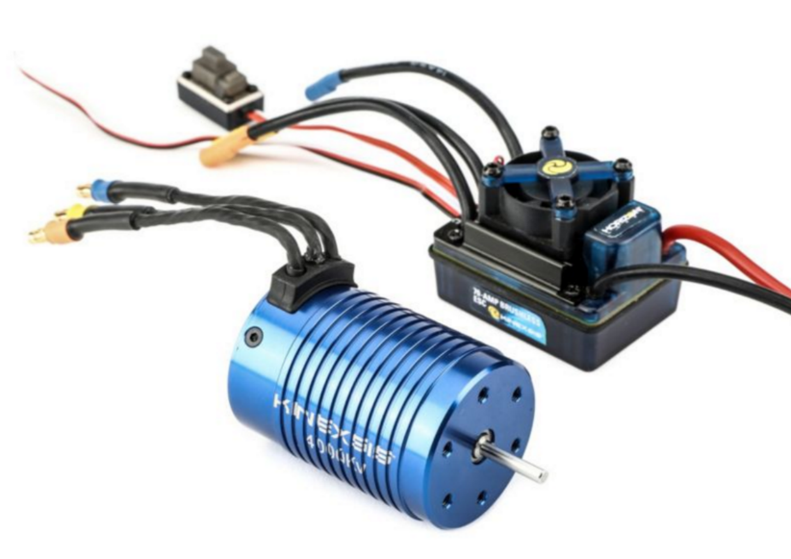

## Figure 8. Kinexis Motor and ESC [8]

### 2.2.4 Arduino Mega 2560

The Arduino is a microcontroller that has 54 Digital I/O Pins, which 14 of can be used as PWM outputs, as shown below in Figure 9. The Arduino Mega is used in the RR2 to provide input from the remote control to the motors to either increase, decrease speed or have a speed of 0 mph. The ESC is connected to the Arduino Mega through the PWM pins. The Xbee shield is connected to the Analog (A0-A5) and the Digital (0-7) on the Arduino. A 9V battery will power the Arduino, since the recommended input voltage is 7-12 V. It has a USB connection, which allows the program to be downloaded from the computer to the Arduino.

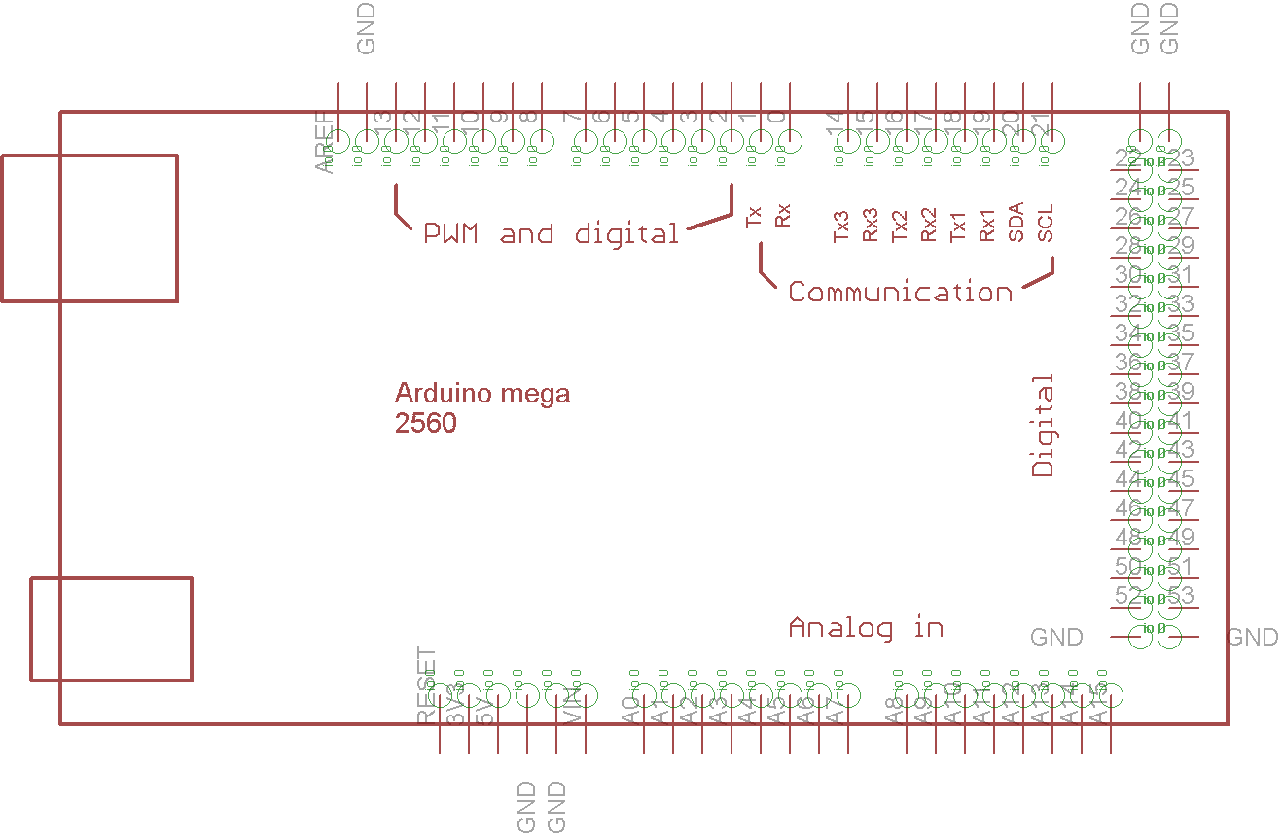

## Figure 9. Arduino Mega 2560 Pin Out [8]

### 2.2.5 Xbee Shield and Xbee Wireless Transmitter

The Xbee Shield mates with the Arduino Mega and extend the capabilities of the microcontroller, which allows the Xbee wireless transmitter to transmit data to the Arduino. The model of the Xbee wireless transmitter is the Xbee 1mW Trace Antenna - Series 1 mates to the Xbee shield as seen in Figure 10.

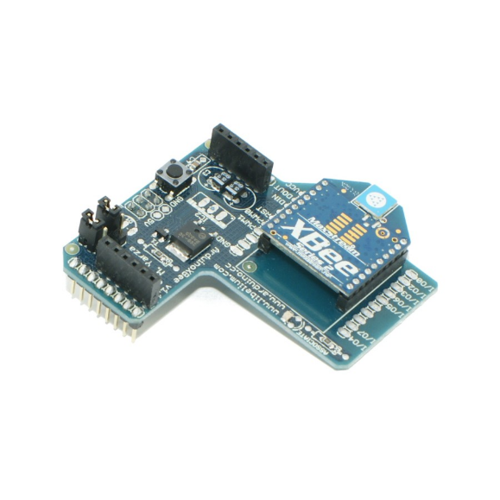

Xbee transmitter

Xbee Shield

## Figure 10. Xbee Shield Mated with Xbee Wireless Transmitter [11]

The Xbee wireless transmitter can transmit data up to 100 feet indoors and operates within the ISM 2.4 GHz frequency. [9]. The Xbee components are capable of transmitting data to another Xbee and receiving data from one as well. The Xbee component a falls under the IEEE 802.15.4 which is a standard for low-rate wireless personal area networks and end device connectivity which includes the Zigbee network that the Xbee uses [10]. The minimum pin connections are shown below. Pin 1 is VCC; with a power supply of 3.3 V. Pin 10 is GND, which is the ground. Pin 3 is DIN, which is data in when that blinks it means that data is being transmitted. Pin 2 is DOUT, which is the data that is being received from another Xbee.

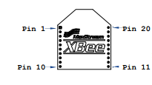

## Figure 11. Pin Out of Xbee Transmitter [9]

### 2.2.6 Remote Control

The remote control is a wireless gamepad that is based on Arduino. The remote control has an Arduino Leonardo, which the Xbee module is connected to, as shown in the figure below. The Arduino Leonardo acts as a boot loader and holds the data and software for the Xbee. The remote control has 2 joysticks, one reset button and 16 programmable buttons. The button controls are discussed in the Operation Manual. It needs an input voltage of 7-12V and is powered by 3 “AAA” batteries.

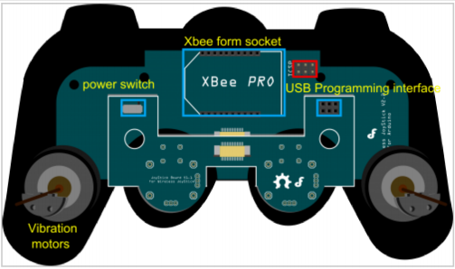

## Figure 12. Pin Out for Remote Control [12]

## 2.3 Data Acquisition

There will be two different types of sensors used for data collection on the RR2. First is the IMU or Inertial Measurement Unit, which calculates orientation, position and velocity. This will be connected to the following pins on the Arduino Pro VCC to 3.3V, ground, SDA and SCL for data transmission. The second are the encoders that will be attached on each axis to measure the speed of the wheels and was requested by the customer. These encoders will each be connected to ground and the Digital PWM pins on the Arduino Pro. The Arduino Pro will be connected to a battery of 5V. The Arduino Pro will in turn be connected to the data logger, which will output the data to an SD card.

## 2.4 Software Diagram

The program that the robot will be operated by will be as shown, in the software diagram below.  The robot will not move until a command is executed on the remote control. If the command is not received the robot will not move and the user will select a command again. Once the robot receives the command, it is to move forward until an obstacle is returned or needs to turn. The remote control commands are discussed in the Operating Instructions.

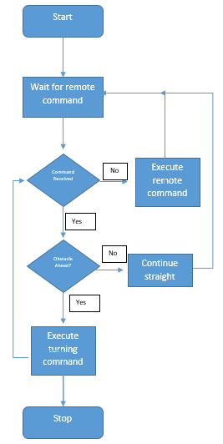

## Figure 13. Software Diagram

# 3.0 Operating and Setup Instructions

**Important Note:** The legs of the RR2 can navigate most floors. However, we strongly recommend you use the RR2 in indoors only. Never use RR2 near stairs. Do not use near water.

**Setup** **Instructions**

1. Place the RR2 on the floor in an indoor environment
2. Make sure two legs for each wheel are touching the ground (one leg is obstructed by the box) and the robot is in standstill position, as shown below.

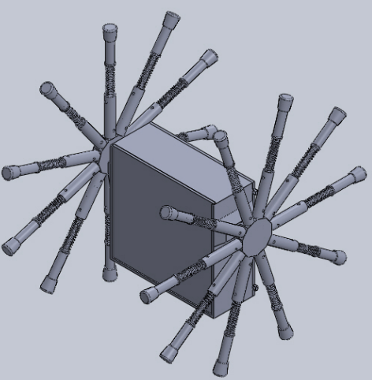

## Figure 14. RR2 Standstill Position

**Powering Up RR2**

1. Slide the lid out of the container.
2. Remove lid from RR2

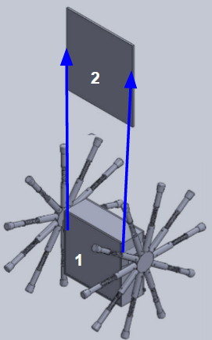

## Figure 15. Lid Removal

1. Make sure one battery labeled as “3S” is connected to each ESC.

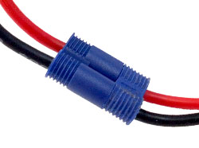

## Figure 16. Battery Connected to ESC Wires [13]

1. Push switch UP into the on position for each ESC.

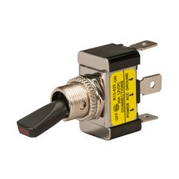

## Figure 17. Switch connected to ESC in OFF Position[14]

1. Make sure the 9V battery is connected to the Arduino. The orange LED should flash on and off when the board is receiving power, as shown circled below.

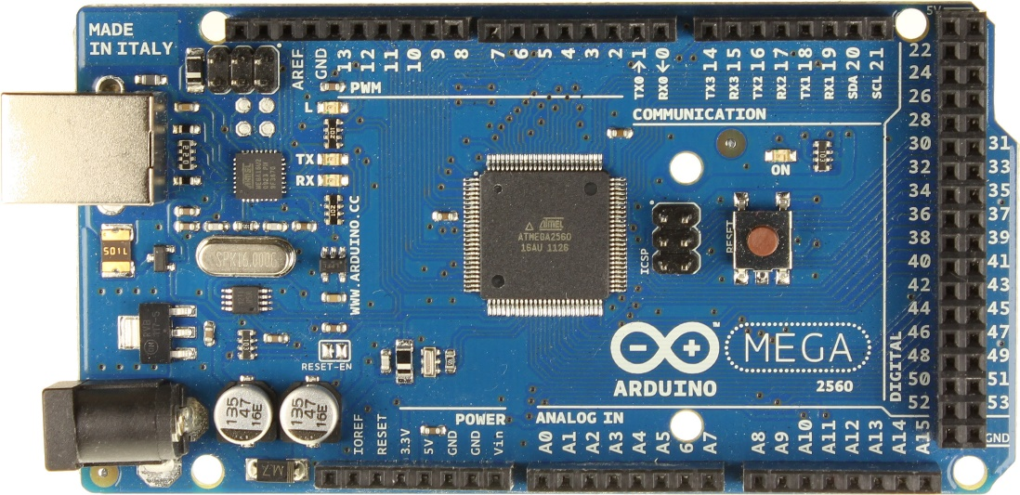

## Figure 18. Showing ON LED on Arduino Mega

1. Slide the lid back onto robot, as shown in Figure 19.

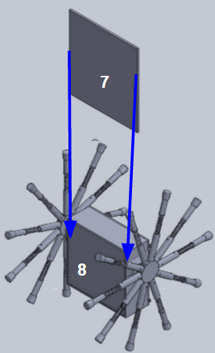

## Figure 19. Sliding Lid

1. RR2 is on and ready for use. Once the robot is powered up, the robot is always on until you power off and disconnect the robot.

**Powering off**

1. Slide the lid off the box, as shown in Figure 15 in the powering on instructions.
2. Push switch for both ESC’s into the down position, as shown in Figure 17.
3. Unplug the “3S” batteries from each ESC.
4. Unplug the 9V battery for the Arduino
5. Make sure no lights are blinking in the box. If so return to steps 2-4.
6. Slide the lid back on the box, as shown in step Figure 19.

**Remote Control Usage**

1. Flip the switch located on the back of the remote to power up the remote

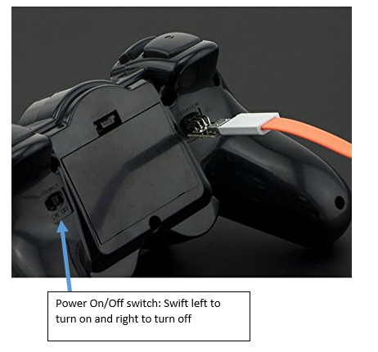

## Figure 20. Remote Control Power Switch

1. The “Mode” light on the remote will light up so you know the remote is turned on.

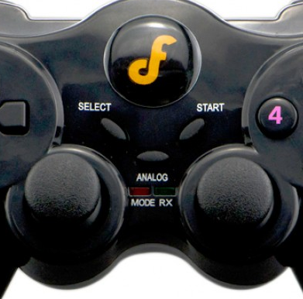

## Figure 21. Showing the Mode light on Remote Control

**Powering Remote Control Off**

1. Push the power button to the right in the off position
2. Make sure the “Mode” light is not lit up on the remote to make sure that it is turned off.

**Remote Control Commands**

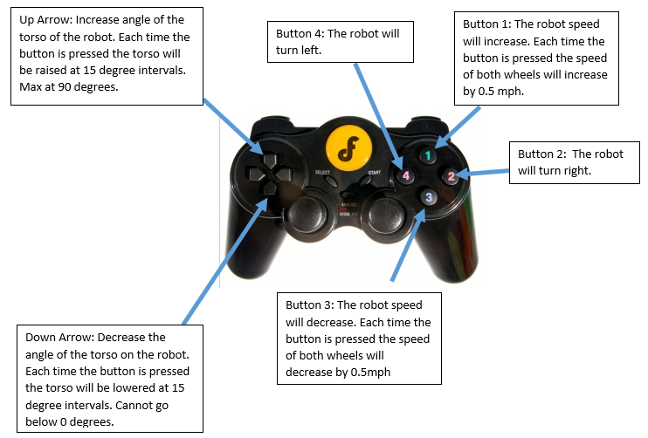

## Figure 22. Remote Control Commands

# Section 4.0 Troubleshooting Instructions

Table 1 contains the most common issues that may occur while using the RR2 and ways to fix those issues.

## Table 1. Issues and Mitigation

|  |  |
| --- | --- |
| **Issue** | **Mitigation** |
| When ON button is pressed on remote control nothing happens | * Make sure that there is power going to Arduino and Remote control * Be sure all batteries are charged * Be sure all wires are connected * Check the Zigbee in the remote control to ensure all connections are secure |
| Data is not being collected from OpenLog or wheel encoder | * Check wires connecting the Open log to the Arduino * Check for power to Arduino * These LEDs can be very useful for debugging. |
| Wheel doesn’t move when forward movement is inputted | * Turn robot off and then back on * Check motors power to ensure a good connection * Check batteries are charged * Check for loose wiring |
| Loss of wireless control of robot | * Ensure range of wireless transmitter is not exceeded. * May be due to interferences- try operating in a different location. |
| Leg falls off while operating | * Inspect for any damages to leg * Do not re-attach if damaged * Re-attach leg and ensure the fastener is tightened if leg is undamaged |
|  |  |

**References**

[1] Xiao, John, Siegwart, and Nourbakhsh. *Robot Locomotion and Kinematics*. Rep. N.p.: n.p.,

2005. Print.

[2] Surya Nurzaman. "Bio-Inspired Motor Control." *Lecture 2: Legged Locomotion*. ETH

Zurich, 25 Sept. 2012. Web.

[3] Coleman, Michael J. "Dynamics And Stability Of A Rimless Spoked Wheel: A Simple 2D

System With Impacts." *Dynamical Systems: An International Journal* 25.2 (2010):

215-238. *Computer Source*. Web.

[4] "IEEE 802.15 WPAN™ Task Group 4 (TG4)." *IEEE 802.15.4*. IEEE, n.d. Web. 20 Sept. 2016.

[5] Hugh, Jack “Dynamic System Modeling and Contols” reative Commons Attribution-Noncommercial-Share Alike 3.0 United States License. Web

[6] "Kinexsis 1/10 4-pole Brushless Motor 4000kv R/c Buggy Truck Kxss1002."*Terapeak*. N.p., n.d. Web. 20 Sept. 2016.

[7] "1/10 4-Pole 4000Kv ESC/Motor Combo | HorizonHobby." *1/10 4-Pole 4000Kv ESC/Motor Combo | HorizonHobby*. N.p., n.d. Web. 20 Sept. 2016.

[8] "Arduino Circuit Schematics Using Eagle CAD Software." *Merry Music*. N.p., n.d. Web. 20 Sept. 2016.

[9] "XBEE Module Manual." *SparkFun*. SparkFun, n.d. Web.

[11] "Arduino XBee Shield." *Liquidware :*. N.p., n.d. Web. 20 Sept. 2016.

[12] "Www.robotshop.com." N.p., n.d. Web. 20 Sept. 2016.

[13] Brian Schneider / Brian Is the Manager, Webmaster, & Social Media Guru for Roger's Hobby Center. He's Been in the Hobby Industry over a Decade, Teaching People the Essentials of the R/C World. He's Written a Number of Helpful Guides, including A Guide to LiPo Batteries. "Dynamite Tazer Programming Guide." *Roger's Hobby Center*. N.p., n.d. Web. 20 Sept. 2016.

# Appendix B – Test Plan

# 1.0 Introduction

The purpose of this test plan is to demonstrate the locomotion of a rimless wheeled robot. Evaluating the RR2 will focus on speed and turning abilities, however other testing procedures will be conducted to verify that the robot performs according to the specifications stated in Appendix A.

# 2.0 Scope

Included in this plan are the testing procedures, facilities, and materials necessary to evaluate the RR2.

# 3.0 Features To Be Tested

The main areas of focus for testing on the RR2 are going to be its performance specifications. Although there will be other tests conducted, the specifications of turning radius and speed will be the team's main concern. Other specifications that will be tested include but are not limited to; weight, dimensions, power supply, electronics configuration, and the controls.

# 

## Table 1. Compliance Matrix

|  |  |  |  |  |
| --- | --- | --- | --- | --- |
| **Item Number** | **Feature Tested** | **Specification** | **Testing Procedure** | **Compliance Status (Pass/Fail)** |
| 1 | Dimensions, radius, width | 1.2.1  1.2.1.1  1.2.1.2 | Test T-1 |  |
| 2 | Weight | 1.2.2 | Test T-2 |  |
| 3 | Number of legs | 1.2.3 | Visual |  |
| 4 | Material | 1.2.4 | Visual |  |
| 5 | Soldering | 1.2.5 | Visual |  |
| 6 | Speed | 2.1  2.7 | Test T-3 |  |
| 7 | Microcontroller | 2.2 | Visual |  |
| 8 | Microcontroller | 2.2.1 | Test T-4 |  |
| 9 | Microcontroller | 2.2.2 | Test T-5 |  |
| 10 | Remote Control | 2.3 | Test T-6 |  |
| 11 | Power Supply | 2.4 | Visual |  |
| 12 | Spring | 2.5 | Visual |  |
| 13 | Turn Radius | 2.6 | Test T-7 |  |

# 4.0 Test Facility

Testing will be conducted inside the Main Building of the UTSA Main Campus. It is imperative to test indoors in order to have a controlled environment and to avoid interference with the microcontroller. The floor of the main building is 12” x 12” tile and they are grouted 8 millimeters. This allows for a smooth and nearly seamless test floor. The test facility will have to be a minimum of 100 feet long in order to meet one of the test requirements. Painter’s tape, a stopwatch and a measuring tape will all be required to set up the test facility.

A computer is needed for the encoder, microcontroller, and to record data. The encoder and IMU have an SD Card (Secure Digital Card) to store the collected data, which will be viewed on the computer. Components of the microcontroller require coding on the Arduino software.

# 5.0 Testing

## 5.1 Visual Verification

Items listed in Table 1 as having a visual testing procedure require no equipment or data analysis. A “pass” will be issued if the feature is existent on the robot.

## 5.2 Test Procedures

|  |  |
| --- | --- |
| Test T-1 |  |
| Method: | Physical test. |
| Evaluated Specifications: | 1.2.1  1.2.1.1  1.2.1.2 |
| Purpose/Scope: | The purpose of this test to verify that the dimensions of the RR2 meet the specifications. |
| Items Under Test: | The whole robot and rimless wheel. |
| Precautions: | Ensure that all electrical systems are powered off. |
| Special Conditions/Limitations: | Test must be witnessed by all team members. |
| Equipment/Facilities: | Tape measure. |
| Data Recording: | Data will be recorded in Table 2. |
| Acceptance Criteria: | The radius of the rimless wheel should not exceed 2 feet. The width of the robot should not exceed 1.5 feet. |
| Procedure: | Using the tape measure, measure the radius of the rimless wheel and the overall width of the robot. |
| Troubleshooting: | None. |
| Post-Test Activities: | None. |

## Table 2. Test T-1 Data

|  |  |
| --- | --- |
| **Dimension** | **Measurement (ft)** |
| Radius of rimless wheel |  |
| Width of robot |  |
| **Pass/Fail** |  |

|  |  |
| --- | --- |
| Test T-2 |  |
| Method: | Physical test. |
| Evaluated Specifications: | 1.2.2 |
| Purpose/Scope: | The purpose of this test to verify that the weight of the RR2 meets the specifications. |
| Items Under Test: | The whole robot, including all electrical components, which are housed in the torso. |
| Precautions: | Ensure that all electrical systems are powered off. |
| Special Conditions/Limitations: | Test must be witnessed by all team members. |
| Equipment/Facilities: | Weight Scale. |
| Data Recording: | Data will be recorded in Table 3. |
| Acceptance Criteria: | The weight of the robot should not exceed 20 pounds. |
| Procedure: | Place the RR2 on the scale and record the weight. |
| Troubleshooting: | None. |
| Post-Test Activities: | None. |

## Table 3. Test T-2 Data

|  |  |
| --- | --- |
|  | **Measurement (lbs)** |
| Weight of RR2 |  |
| **Pass/Fail** |  |

|  |  |
| --- | --- |
| Test T-3 |  |
| Method: | Mechanical test and analysis. |
| Evaluated Specifications: | 2.1  2.7 |
| Purpose/Scope: | The purpose of this test is to measure the speed of the RR2 and verify that it meets the specifications. |
| Items Under Test: | The entire robot and its components. |
| Precautions: | Ensure the test area has enough space, is in a still position before starting, and be gentle with the controls to avoid damage and injury. |
| Special Conditions/Limitations: | Test must be witnessed by all team members. After each test run, the encoder data will need to be collected from the microcontroller. |
| Equipment/Facilities: | The RR2 will be tested indoors on flat tile without grout spacing. A computer, data cord, tape measure, and tape are required. |
| Data Recording: | Data will be recorded in Table 4. An encoder will be attached to the axle and record the number of revolutions over a period of time. Using Equation 1, calculations will be made to convert the recorded angular speed (rpm) into linear speed (mph). |
| Acceptance Criteria: | The RR2 must travel at a speed of 5 mph for a distance of 100 feet. |
| Procedure: | Using the tape measure and tape, mark the starting line and the finish line 100 feet away. Place the RR2 at the start line. Make a test run and start the stopwatch when the RR2 begins to move. Stop the stopwatch when the RR2 reaches the finish line. Use the computer and data cord to load the collected data from the encoder. |
| Troubleshooting: | Verify correct wiring, make sure electrical components are not overheating, and ensure the battery has enough power. |
| Post-Test Activities: | After the final test run, all power need to be switched off, batteries need to be unplugged, and all electronics inside the torso will need time to cool to room temperature before transporting. |

## Table 4. Test T-3 Data

|  |  |
| --- | --- |
| **Test Run** | **Measurement (mph)** |
| Test Run 1 |  |
| Test Run 2 |  |
| Test Run 3 |  |
| Test Run 4 |  |
| Test Run 5 |  |
| **Pass/Fail** |  |

|  |  |
| --- | --- |
| Test T-4 |  |
| Method: | Electrical Test and Analysis |
| Evaluated Specifications: | 2.2.1 |
| Purpose/Scope: | The purpose of this test is to measure the flash memory on the Arduino Mega to make sure it does not go above the maximum 256 KB. |
| Items Under Test: | Arduino Mega 2560. |
| Precautions: | Ensure that there is no water in the testing area. |
| Special Conditions/Limitations: | Test must be witnessed by all team members. |
| Equipment/Facilities: | Must be tested indoors with a computer with Arduino software, the Arduino Mega 2560 and USB Cable type A/B. |
| Data Recording: | Data will be recorded in Table 5. |
| Acceptance Criteria: | The flash memory must not exceed 256 KB. |
| Procedure: | Compile the program for the robot using the Arduino Software. Check the bottom of the Arduino program window and it will show “Binary Sketch Size”. Report this number in the table below. |
| Troubleshooting: | Make sure electrical components are not overheating and check for errors when compiling the program |
| Post-Test Activities: | After the test the Arduino needs to be unplugged from the computer and the battery disconnected from the Arduino. |

# 

## Table 5. Test T-4 Data

|  |  |
| --- | --- |
|  | **Pass/Fail** |
| Test Run 1 |  |
| **Pass/Fail** |  |

|  |  |
| --- | --- |
| Test T-5 |  |
| Method: | Electrical Test and Analysis |
| Evaluated Specifications: | 2.2.2 |
| Purpose/Scope: | The purpose of this test is to measure make sure the Arduino works and the correct voltages are being applied to the various pins. |
| Items Under Test: | 9 Battery. |
| Precautions: | Ensure that there is no water in the testing area. |
| Special Conditions/Limitations: | Test must be witnessed by all team members. |
| Equipment/Facilities: | Digital Multimeter. |
| Data Recording: | Data will be recorded in Table 6. |
| Acceptance Criteria: | The voltage should be between 7V-12V |
| Procedure: | Adjust the Digital Multimeter to DC Voltage. Connect the black probe to the negative side of the battery and the red probe to the positive side of the battery. |
| Troubleshooting: | Make sure electrical components are not overheating. |
| Post-Test Activities: | Turn off all power. |

## Table 6. Test T-5 Data

|  |  |
| --- | --- |
|  | **Pass/Fail** |
| Test Run 1 |  |
| **Pass/Fail** |  |

|  |  |
| --- | --- |
| Test T-6 |  |
| Method: | Electrical test. |
| Evaluated Specifications: | 2.3 |
| Purpose/Scope: | The purpose of this test is verify that the remote control is able to successfully communicate to the microcontroller. |
| Items Under Test: | Remote control and RR2 including, but not limited to, Zigbee module and motor. |
| Precautions: | Ensure the test area has enough space, is in a still position before starting, and be gentle with the controls to avoid damage and injury. |
| Special Conditions/Limitations: | Test must be witnessed by all team members |
| Equipment/Facilities: | The RR2 will be tested indoors on flat tile without grout spacing. Tape measure and tape is required. |
| Data Recording: | Data will be recorded in Table 5. |
| Acceptance Criteria: | The remote control must successfully communicate with the RR2 from a distance of at least 50 feet. |
| Procedure: | Using the tape measure and tape, set the RR2 at a distance of 50 feet from the remote control. First turn on the remote control and robot. Press the appropriate buttons to perform the following movements: stop, increase speed, decrease speed, and turn. This test will be repeated for distances of 60 feet, 70 feet, 80 feet, 90 feet and 100 feet. |
| Troubleshooting: | Verify correct wiring, make sure electrical components are not overheating, and ensure the battery has enough power. |
| Post-Test Activities: | After the final test, all power need to be switched off, batteries need to be unplugged, and all electronics inside the torso will need time to cool to room temperature before transporting. |

## Table 7. Test T-6 Data

|  |  |
| --- | --- |
| **Movement** | **Pass/Fail** |
| Stop |  |
| Increase Speed |  |
| Decrease Speed |  |
| Turn |  |
| **Pass/Fail** |  |

|  |  |
| --- | --- |
| Test T-7 |  |
| Method: | Mechanical test and analysis. |
| Evaluated Specifications: | 2.6 |
| Purpose/Scope: | The purpose of this test is to measure the turning radius of the RR2 and verify that it meets the specifications. |
| Items Under Test: | The entire robot and its components. |
| Precautions: | Ensure the test area has enough space, is in a still position before starting, and be gentle with the controls to avoid damage and injury. |
| Special Conditions/Limitations: | Test must be witnessed by all team members. |
| Equipment/Facilities: | The robot will be tested indoors on flat tile without grout spacing. Tape measure and tape are required. |
| Data Recording: | Data will be recorded in Table 6. |
| Acceptance Criteria: | The RR2 must make a complete turn within the 5 foot radius circle. |
| Procedure: | Using the tape measure and tape, mark a five foot circle on the floor. Position the outer edge of the robot on the tape line. Run the robot to make a turn. |
| Troubleshooting: | Verify correct wiring, make sure electrical components are not overheating, and ensure the battery has enough power. |
| Post-Test Activities: | After the final test, all power need to be switched off, batteries need to be unplugged, and all electronics inside the torso will need time to cool to room temperature before transporting. |

## Table 8. Test T-7 Data

|  |  |
| --- | --- |
| **Movement** | **Pass/Fail** |
| Test Run 1 |  |
| Test Run 2 |  |
| Test Run 3 |  |
| **Pass/Fail** |  |

# 6.0 Data Analysis

## 6.1 Speed

The ratio of distance over time will calculate the speed of the robot. The speed will also be calculated by the encoder inside the robot. The encoder will consist of a sensor and a gear. The sensor detects the gear teeth and reports it as changes in voltage. The changes of voltage are graphed as a function of time. With the graph you can use the equation below to calculate speed.

## Equation 1. Speed

## 6.2 Turning Radius

The turning radius is the smallest circular turn one is able to achieve, measured from the origin of the circle to the outer edge of the RR2. To calculate turn radius, the vehicle would start a defined position and would turn one direction as much as it could. The vehicle would turn in a circle and come back to the spot it started. If you track the measure the radius of the vehicle’s path, this will be the turning radius.

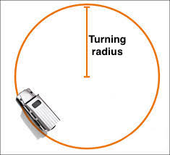

## Figure 1. Turning Radius

## 6.3 Voltage Test

The voltage drop among each component can be calculated by analyzing the closed loops on the circuit schematic. Each electrical component has a specified voltage requirement. Measured values of the voltage drop on each component will be recorded and compared to the components specifications.

# 7.0 Schedule

A detailed timeline for the testing period is included below in Figure 2. Testing will conclude on November 4, 2016. The breakdown of the testing process is as follows:

1. Test Plan (34 days)
2. Fabrication and assembly (32 days)
3. Testing (12 days)
4. Data analysis and reporting (12 days)

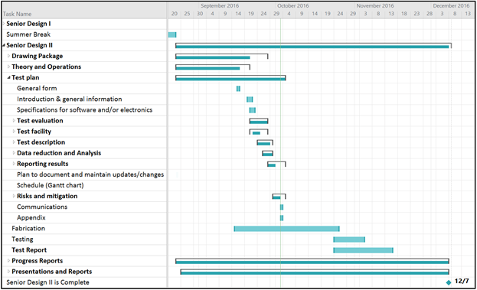

## Figure 2. Gantt Chart

# 8.0 Program Risks and Mitigation

There are two risks to consider in the fabrication process and one risk in performance. The first risk is the possibility of acquiring materials late. This can be remedied by starting assembly on available parts and testing on individual components during this idle time. The second risk is the possibility of the 3D printed parts not printing correctly. It is recommended to print a single part to check for accuracy before printing multiple duplicate parts. The last risk is associated with the remote control not communicating properly with the microcontroller. To avoid damaging the robot or personal injury, it is encouraged to ensure the performance of these components before assembling them to the RR2.

# 9.0 Communications

Communications on testing progress and all aspects of the project are available during bi-weekly meetings. The primary contact for ABC Ngineering is Aspen Meineke, Project Manager (210-954-4723)

# Appendix C – Test Report

# 1.0 Introduction

The purpose of this test plan is to demonstrate the locomotion of a rimless wheeled robot. Evaluating the RR2 will focus on speed and turning abilities, however other testing procedures will be conducted to verify that the robot performs according to the specifications stated in Appendix A.

# 2.0 Scope

Included in this plan are the testing procedures, facilities, and materials necessary to evaluate the RR2.

# 3.0 Features To Be Tested

The main areas of focus for testing on the RR2 are going to be its performance specifications. Although there will be other tests conducted, the specifications of turning radius and speed will be the team's main concern. Other specifications that will be tested include but are not limited to; weight, dimensions, power supply, electronics configuration, and the controls.

## Table 1. Compliance Matrix

|  |  |  |  |  |
| --- | --- | --- | --- | --- |
| **Item Number** | **Feature Tested** | **Specification** | **Testing Procedure** | **Compliance Status (Pass/Fail)** |
| 1 | Dimensions, radius, width | 1.2.1  1.2.1.1  1.2.1.2 | Test T-1 | Pass |
| 2 | Weight | 1.2.2 | Test T-2 | Pass |
| 3 | Number of legs | 1.2.3 | Visual | Pass |
| 4 | Material | 1.2.4 | Visual | Pass |
| 5 | Soldering | 1.2.5 | Visual | Pass |
| 6 | Speed | 2.1  2.7 | Test T-3 | Pass |
| 7 | Microcontroller | 2.2 | Visual | Pass |
| 8 | Microcontroller | 2.2.1 | Test T-4 | Pass |
| 9 | Microcontroller | 2.2.2 | Test T-5 | Pass |
| 10 | Remote Control | 2.3 | Test T-6 | Pass |
| 11 | Power Supply | 2.4 | Visual | Pass |
| 12 | Spring | 2.5 | Visual | Pass |
| 13 | Turn Radius | 2.6 | Test T-7 | Pass |

# 

## Table 2. Test Matrix

|  |  |  |
| --- | --- | --- |
| **Test** | **Type** | **Description** |
| T-1 | Quality | Verify the dimensions of the RR2 |
| T-2 | Quality | Verify the weight of the RR2 |
| T-3 | Performance | Measure speed of the RR2 when going straight |
| T-4 | Performance | Measure the flash memory of the microcontroller |
| T-5 | Performance, Quality | Measure the power limitations of the microcontroller |
| T-6 | Performance, Safety | Verify that the remote control is able to stop, increase speed, decrease speed, and turn the RR2 |
| T-7 | Performance | Measure the turning radius |

# 4.0 Test Facility

Testing will be conducted inside the Main Building of the UTSA Main Campus. It is imperative to test indoors in order to have a controlled environment and to avoid interference with the microcontroller. The floor of the main building is 12” x 12” tile and they are grouted 8 millimeters. This allows for a smooth and nearly seamless test floor. The test facility will have to be a minimum of 100 feet long in order to meet one of the test requirements. Painters tape, a stopwatch and a measuring tape will all be required to set up the test facility.

A computer is needed for the encoder, microcontroller, and to record data. The encoder and IMU have an SD Card (Secure Digital Card) to store the collected data, which will be viewed on the computer. Components of the microcontroller require coding on the Arduino software.

# 5.0 Testing

## 5.1 Visual Verification

Items listed in Table 1 as having a visual testing procedure require no equipment or data analysis. A “pass” will be issued if the feature is existent on the robot.

## 5.2 Test Procedures

|  |  |
| --- | --- |
| Test T-1 |  |
| Method: | Physical test. |
| Evaluated Specifications: | 1.2.1  1.2.1.1  1.2.1.2 |
| Purpose/Scope: | The purpose of this test to verify that the dimensions of the RR2 meet the specifications. |
| Items Under Test: | The whole robot and rimless wheel. |
| Precautions: | Ensure that all electrical systems are powered off. |
| Special Conditions/Limitations: | Test must be witnessed by all team members. |
| Equipment/Facilities: | Tape measure. |
| Data Recording: | Data will be recorded in Table 2. |
| Acceptance Criteria: | The radius of the rimless wheel should not exceed 2 feet. The width of the robot should not exceed 1.5 feet. |
| Procedure: | Using the tape measure, measure the radius of the rimless wheel and the overall width of the robot. |
| Troubleshooting: | None. |
| Post-Test Activities: | None. |

|  |  |  |  |  |  |  |
| --- | --- | --- | --- | --- | --- | --- |
| Test T-2 | | | |  | | |
| Method: | | | | Physical test. | | |
| Evaluated Specifications: | | | | 1.2.2 | | |
| Purpose/Scope: | | | | The purpose of this test to verify that the weight of the RR2 meets the specifications. | | |
| Items Under Test: | | | | The whole robot, including all electrical components, which are housed in the torso. | | |
| Precautions: | | | | Ensure that all electrical systems are powered off. | | |
| Special Conditions/Limitations: | | | | Test must be witnessed by all team members. | | |
| Equipment/Facilities: | | | | Weight Scale. | | |
| Data Recording: | | | | Data will be recorded in Table 3. | | |
| Acceptance Criteria: | | | | The weight of the robot should not exceed 20 pounds. | | |
| Procedure: | | | | Place the RR2 on the scale and record the weight. | | |
| Troubleshooting: | | | | None. | | |
| Post-Test Activities: | | | | None. | | |
| Test T-3 | | | |  | | |
| Method: | | | | Mechanical test and analysis. | | |
| Evaluated Specifications: | | | | 2.1  2.7 | | |
| Purpose/Scope: | | | | The purpose of this test is to measure the speed of the RR2 and verify that it meets the specifications. | | |
| Items Under Test: | | | | The entire robot and its components. | | |
| Precautions: | | | | Ensure the test area has enough space, is in a still position before starting, and be gentle with the controls to avoid damage and injury. | | |
| Special Conditions/Limitations: | | | | Test must be witnessed by all team members. After each test run, the encoder data will need to be collected from the microcontroller. | | |
| Equipment/Facilities: | | | | The RR2 will be tested indoors on flat tile without grout spacing. A computer, data cord, tape measure, and tape are required. | | |
| Data Recording: | | | | Data will be recorded in Table 4. An encoder will be attached to the axle and record the number of revolutions over a period of time. Using Equation 1, calculations will be made to convert the recorded angular speed (rpm) into linear speed (mph). | | |
| Acceptance Criteria: | | | | The RR2 must travel at a speed of 5 mph for a distance of 100 feet. | | |
| Procedure: | | | | Using the tape measure and tape, mark the starting line and the finish line 100 feet away. Place the RR2 at the start line. Make a test run and start the stopwatch when the RR2 begins to move. Stop the stopwatch when the RR2 reaches the finish line. Use the computer and data cord to load the collected data from the encoder. | | |
| Troubleshooting: | | | | Verify correct wiring, make sure electrical components are not overheating, and ensure the battery has enough power. | | |
| Post-Test Activities: | | | | After the final test run, all power need to be switched off, batteries need to be unplugged, and all electronics inside the torso will need time to cool to room temperature before transporting. | | |
| Test T-4 | | | | |  |
| Method: | | | | | Electrical Test and Analysis |
| Evaluated Specifications: | | | | | 2.2.1 |
| Purpose/Scope: | | | | | The purpose of this test is to measure the flash memory on the Arduino Mega to make sure it does not go above the maximum 256 KB. |
| Items Under Test: | | | | | Arduino Mega 2560. |
| Precautions: | | | | | Ensure that there is no water in the testing area. |
| Special Conditions/Limitations: | | | | | Test must be witnessed by all team members. |
| Equipment/Facilities: | | | | | Must be tested indoors with a computer with Arduino software, the Arduino Mega 2560 and USB Cable type A/B. |
| Data Recording: | | | | | Data will be recorded in Table 5. |
| Acceptance Criteria: | | | | | The flash memory must not exceed 256 KB. |
| Procedure: | | | | | Compile the program for the robot using the Arduino Software. Check the bottom of the Arduino program window and it will show “Binary Sketch Size”. Report this number in the table below. |
| Troubleshooting: | | | | | Make sure electrical components are not overheating and check for errors when compiling the program |
| Post-Test Activities: | | | | | After the test the Arduino needs to be unplugged from the computer and the battery disconnected from the Arduino. |
| Test T-5 | | |  | | | |
| Method: | | | Electrical Test and Analysis | | | |
| Evaluated Specifications: | | | 2.2.2 | | | |
| Purpose/Scope: | | | The purpose of this test is to measure make sure the Arduino works and the correct voltages are being applied to the various pins. | | | |
| Items Under Test: | | | 9 Battery. | | | |
| Precautions: | | | Ensure that there is no water in the testing area. | | | |
| Special Conditions/Limitations: | | | Test must be witnessed by all team members. | | | |
| Equipment/Facilities: | | | Digital Multimeter. | | | |
| Data Recording: | | | Data will be recorded in Table 6. | | | |
| Acceptance Criteria: | | | The voltage should be between 7V-12V | | | |
| Procedure: | | | Adjust the Digital Multimeter to DC Voltage. Connect the black probe to the negative side of the battery and the red probe to the positive side of the battery. | | | |
| Troubleshooting: | | | Make sure electrical components are not overheating. | | | |
| Post-Test Activities: | | | Turn off all power. | | | |
| Test T-6 | |  | | | |
| Method: | | Electrical test. | | | |
| Evaluated Specifications: | | 2.3 | | | |
| Purpose/Scope: | | The purpose of this test is verify that the remote control is able to successfully communicate to the microcontroller. | | | |
| Items Under Test: | | Remote control and RR2 including, but not limited to, Zigbee module and motor. | | | |
| Precautions: | | Ensure the test area has enough space, is in a still position before starting, and be gentle with the controls to avoid damage and injury. | | | |
| Special Conditions/Limitations: | | Test must be witnessed by all team members | | | |
| Equipment/Facilities: | | The RR2 will be tested indoors on flat tile without grout spacing. Tape measure and tape is required. | | | |
| Data Recording: | | Data will be recorded in Table 5. | | | |
| Acceptance Criteria: | | The remote control must successfully communicate with the RR2 from a distance of at least 50 feet. | | | |
| Procedure: | | Using the tape measure and tape, set the RR2 at a distance of 50 feet from the remote control. First turn on the remote control and robot. Press the appropriate buttons to perform the following movements: stop, increase speed, decrease speed, and turn. This test will be repeated for distances of 60 feet, 70 feet, 80 feet, 90 feet and 100 feet. | | | |
| Troubleshooting: | | Verify correct wiring, make sure electrical components are not overheating, and ensure the battery has enough power. | | | |
| Post-Test Activities: | | After the final test, all power need to be switched off, batteries need to be unplugged, and all electronics inside the torso will need time to cool to room temperature before transporting. | | | |

|  |  |
| --- | --- |
| Test T-7 |  |
| Method: | Mechanical test and analysis. |
| Evaluated Specifications: | 2.6 |
| Purpose/Scope: | The purpose of this test is to measure the turning radius of the RR2 and verify that it meets the specifications. |
| Items Under Test: | The entire robot and its components. |
| Precautions: | Ensure the test area has enough space, is in a still position before starting, and be gentle with the controls to avoid damage and injury. |
| Special Conditions/Limitations: | Test must be witnessed by all team members. |
| Equipment/Facilities: | The robot will be tested indoors on flat tile without grout spacing. Tape measure and tape are required. |
| Data Recording: | Data will be recorded in Table 6. |
| Acceptance Criteria: | The RR2 must make a complete turn within the 5 foot radius circle. |
| Procedure: | Using the tape measure and tape, mark a five foot circle on the floor. Position the outer edge of the robot on the tape line. Run the robot to make a turn. |
| Troubleshooting: | Verify correct wiring, make sure electrical components are not overheating, and ensure the battery has enough power. |
| Post-Test Activities: | After the final test, all power need to be switched off, batteries need to be unplugged, and all electronics inside the torso will need time to cool to room temperature before transporting. |

# 6.0 Data Analysis

## 6.1 Speed

The ratio of distance over time will calculate the speed of the robot. The speed will also be calculated by the encoder inside the robot. The encoder will consist of a sensor and a gear. The sensor detects the gear teeth and reports it as changes in voltage. The changes of voltage are graphed as a function of time. With the graph you can use the equation below to calculate speed.

## Equation 1. Speed

## 6.2 Turning Radius

The turning radius is the smallest circular turn one is able to achieve, measured from the origin of the circle to the outer edge of the RR2. To calculate turn radius, the vehicle would start a defined position and would turn one direction as much as it could. The vehicle would turn in a circle and come back to the spot it started. If you track the measure the radius of the vehicle’s path, this will be the turning radius.



## Figure 1. Turning Radius

## 6.3 Voltage Test

The voltage drop among each component can be calculated by analyzing the closed loops on the circuit schematic. Each electrical component has a specified voltage requirement. Measured values of the voltage drop on each component will be recorded and compared to the components specifications.

# 7.0 Results

Results are either pass or fail based on the acceptance criteria for each procedure.

## Table 3. Test T-1 Data

|  |  |
| --- | --- |
| **Dimension** | **Measurement** |
| Radius of rimless wheel | 10 in |
| Width of robot | 1 ft, 0.5 in |
| **Pass/Fail** | Pass |

## Table 4. Test T-2 Data

|  |  |
| --- | --- |
|  | **Measurement** |
| Weight of RR2 | 13.2 lbs |
| **Pass/Fail** | Pass |

## Table 5. Test T-3 Data

|  |  |
| --- | --- |
| **Test Run** | **Measurement** |
| Test Run 1 | 4.6 mph |
| Test Run 2 | 3.8 mph |
| Test Run 3 | 5.6 mph |
| Test Run 4 | 6.1 mph |
| Test Run 5 | 5.9 mph |
| **Pass/Fail** | Pass |

## Table 6. Test T-4 Data

|  |  |
| --- | --- |
|  | **Memory** |
| Test Run 1 | 9.7 kB |
| **Pass/Fail** | Pass |

## Table 7. Test T-5 Data

|  |  |
| --- | --- |
|  | **Measurement** |
| Test Run 1 | 8.4 V |
| **Pass/Fail** | Pass |

## Table 8. Test T-6 Data

|  |  |
| --- | --- |
| **Movement** | **Pass/Fail** |
| Stop | Pass |
| Increase Speed | Pass |
| Decrease Speed | Pass |
| Turn | Pass |
| **Pass/Fail** | Pass |

## Table 9. Test T-7 Data

|  |  |
| --- | --- |
| **Movement** | **Measurement** |
| Test Run 1 | 1.6 ft |
| Test Run 2 | 2.3 ft |
| Test Run 3 | 2.1 ft |
| **Pass/Fail** | Pass |

# 8.0 Schedule

A timeline for the testing period is included below in Figure 2. The testing portion of this project concluded on November 15, 2016.

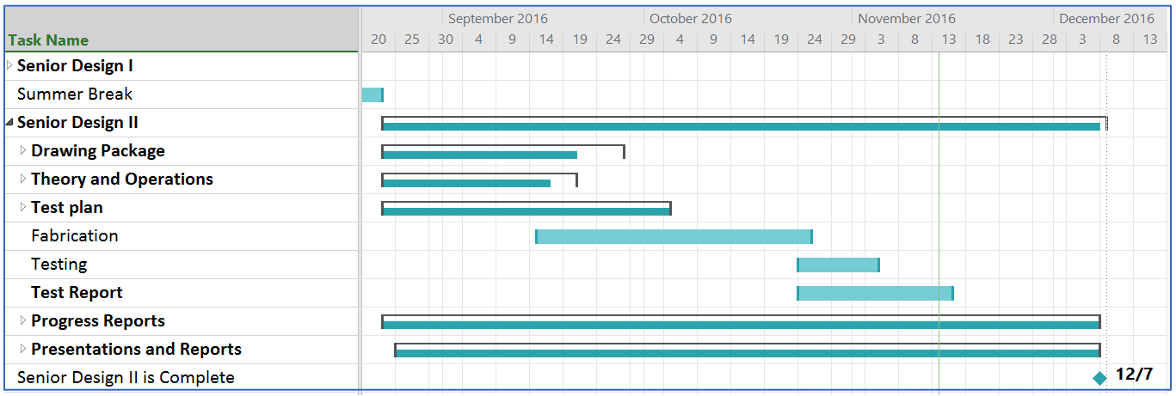

## Figure 2. Gantt Chart

# 9.0 Conclusions and Recommendations

The Roadrunner Robot 2 passed all specifications. ABC Ngineering will keep working to achieve more consistent results.

# 10.0 Communications

Communications on the testing program and all aspects of the project are available during bi-weekly meetings. The primary contact for ABC Ngineering is Aspen Meineke, Project Manager (210-954-4723).

# Appendix D – Design Drawings

## RR2 Assembly.jpgFigure 1. Roadrunner Robot 2

## 

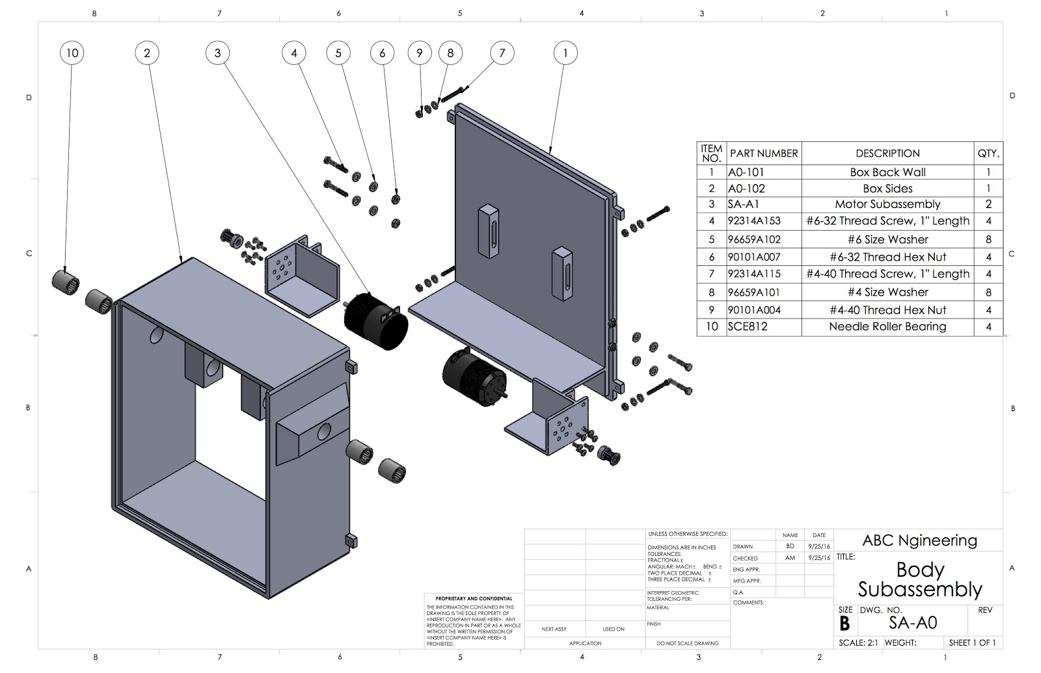

## Figure 2. Body Subassembly

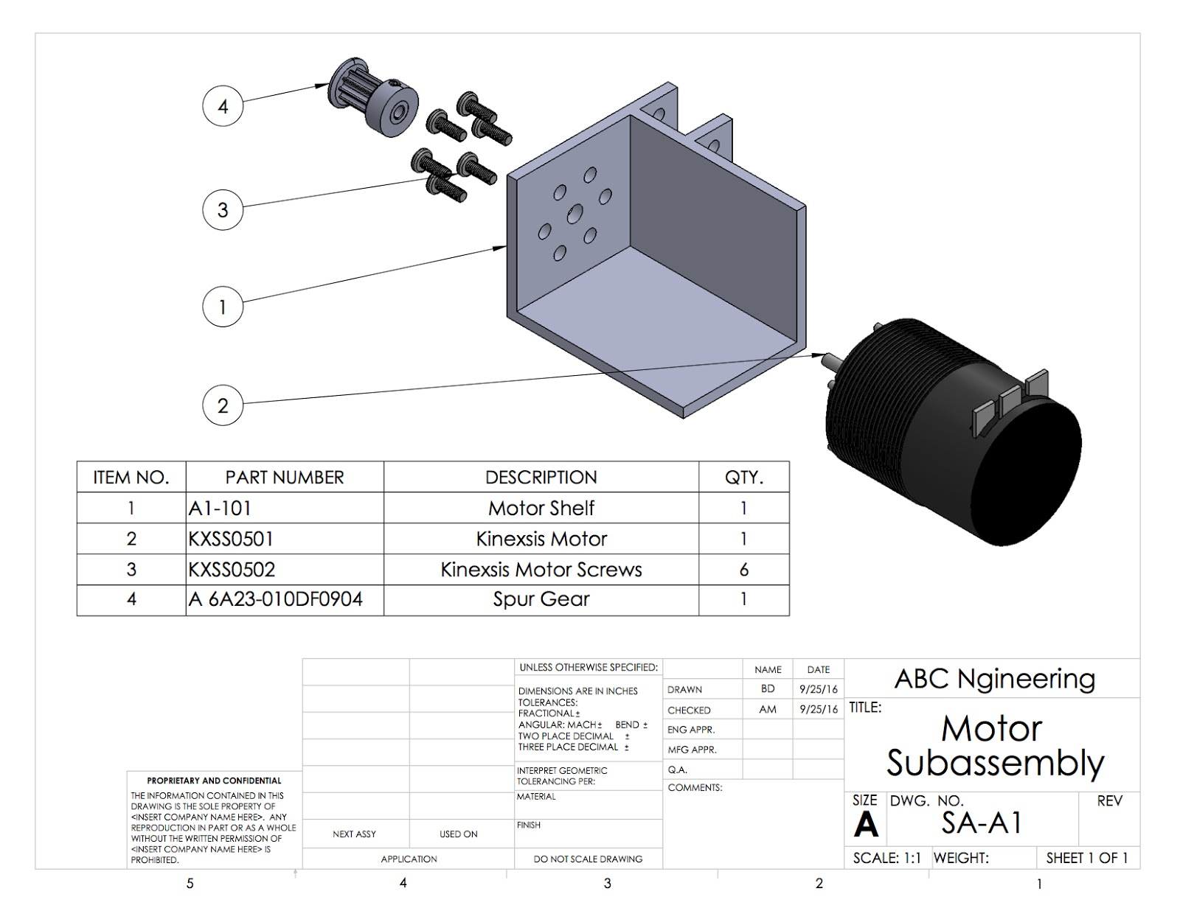

**Figure 3. Motor Subassembly**

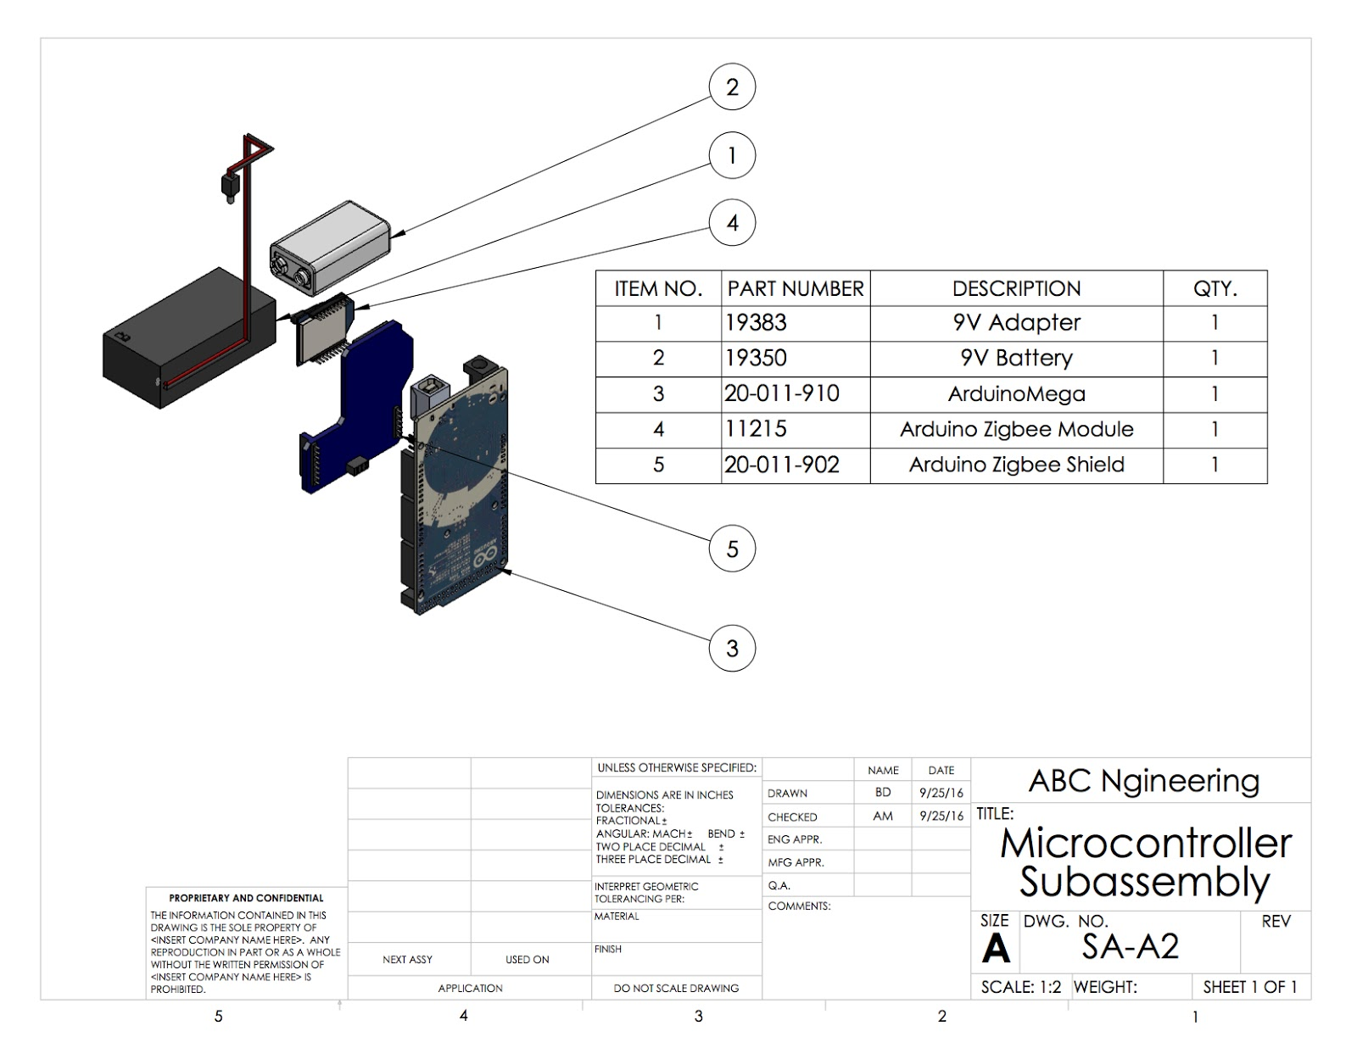

**Figure 4. Microcontroller Subassembly**

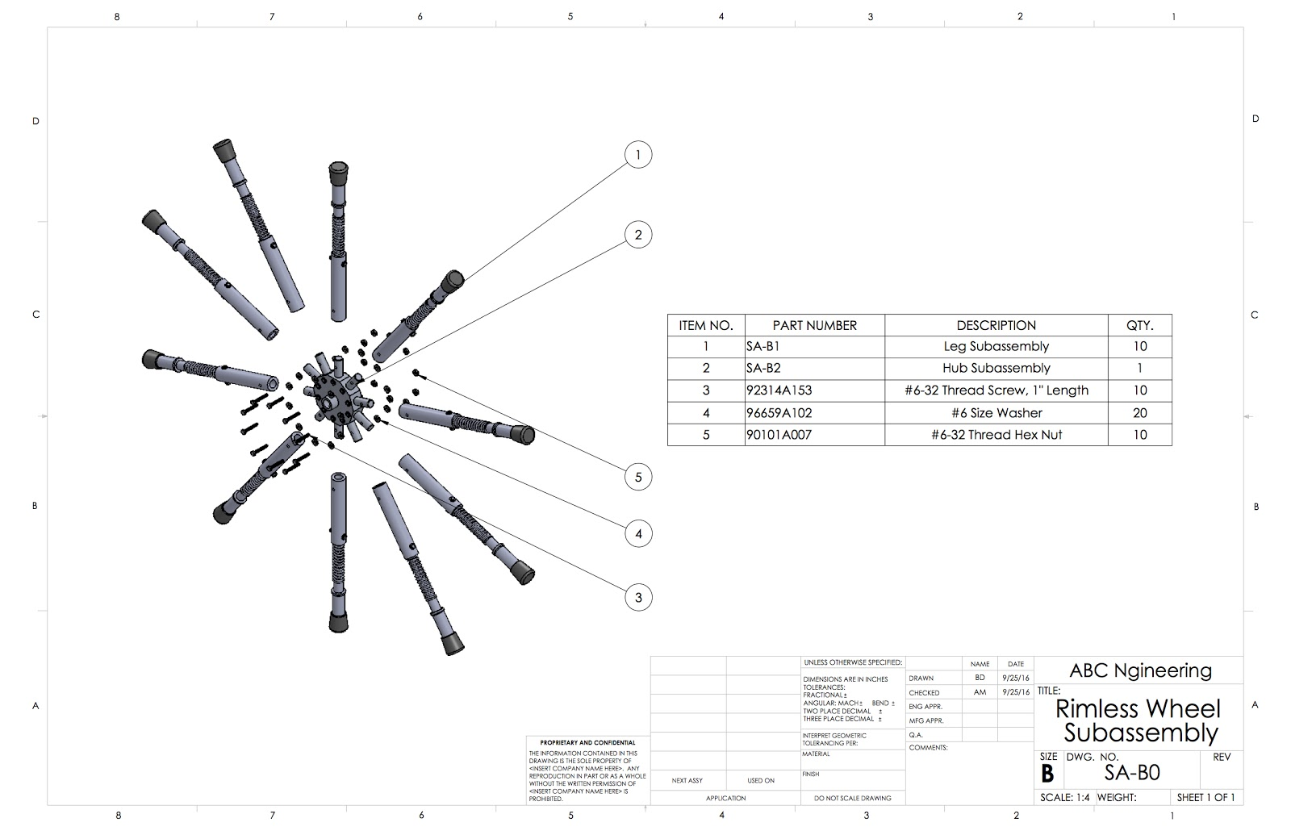

**Figure 5. Rimless Wheel Subassembly**

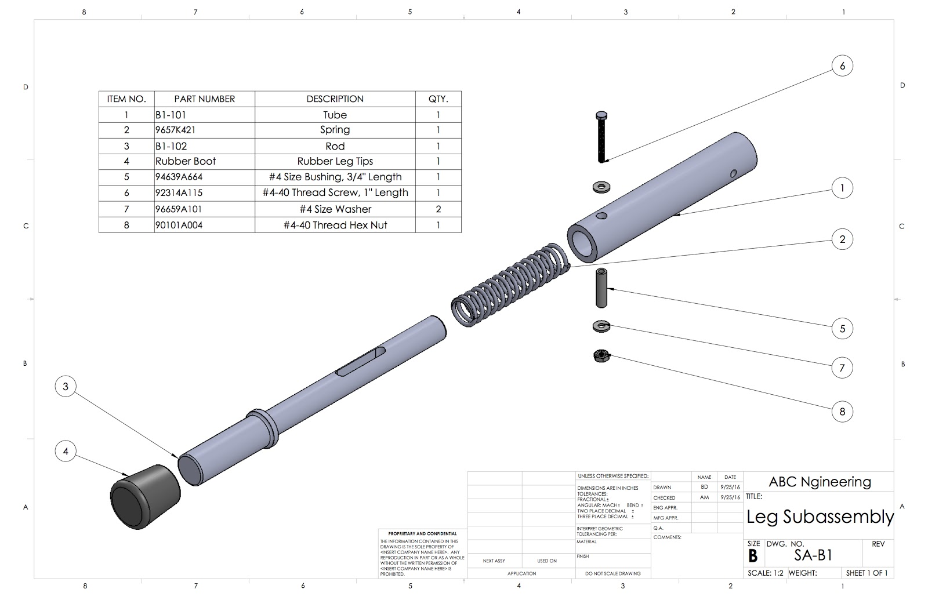

**Figure 6. Leg Subassembly**

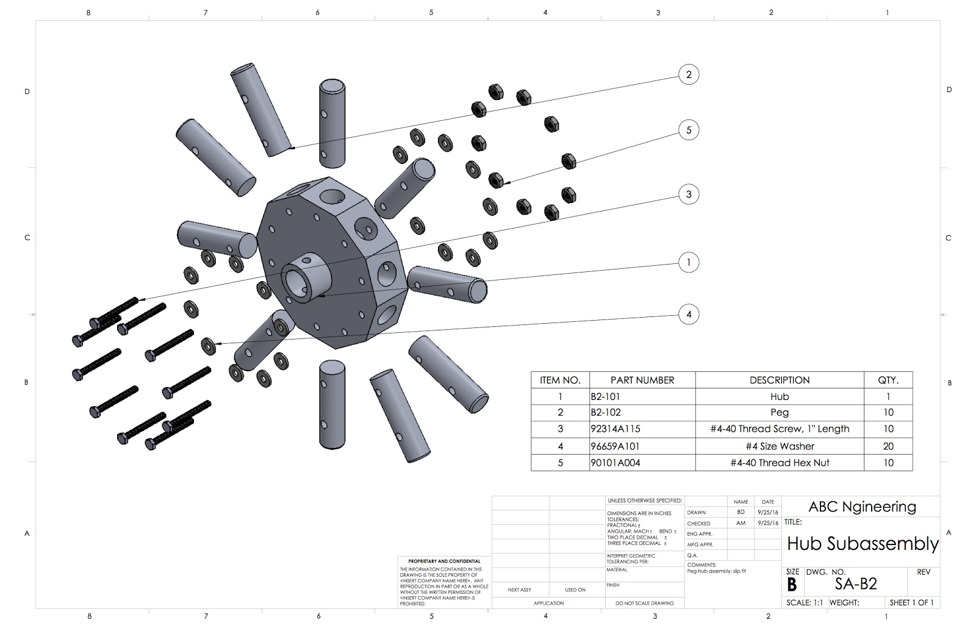

**Figure 7. Hub Subassembly**

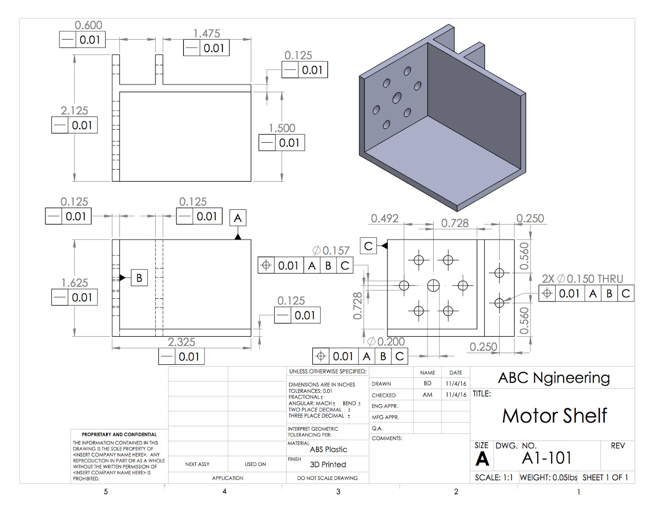

**Figure 8. Motor Shelf**

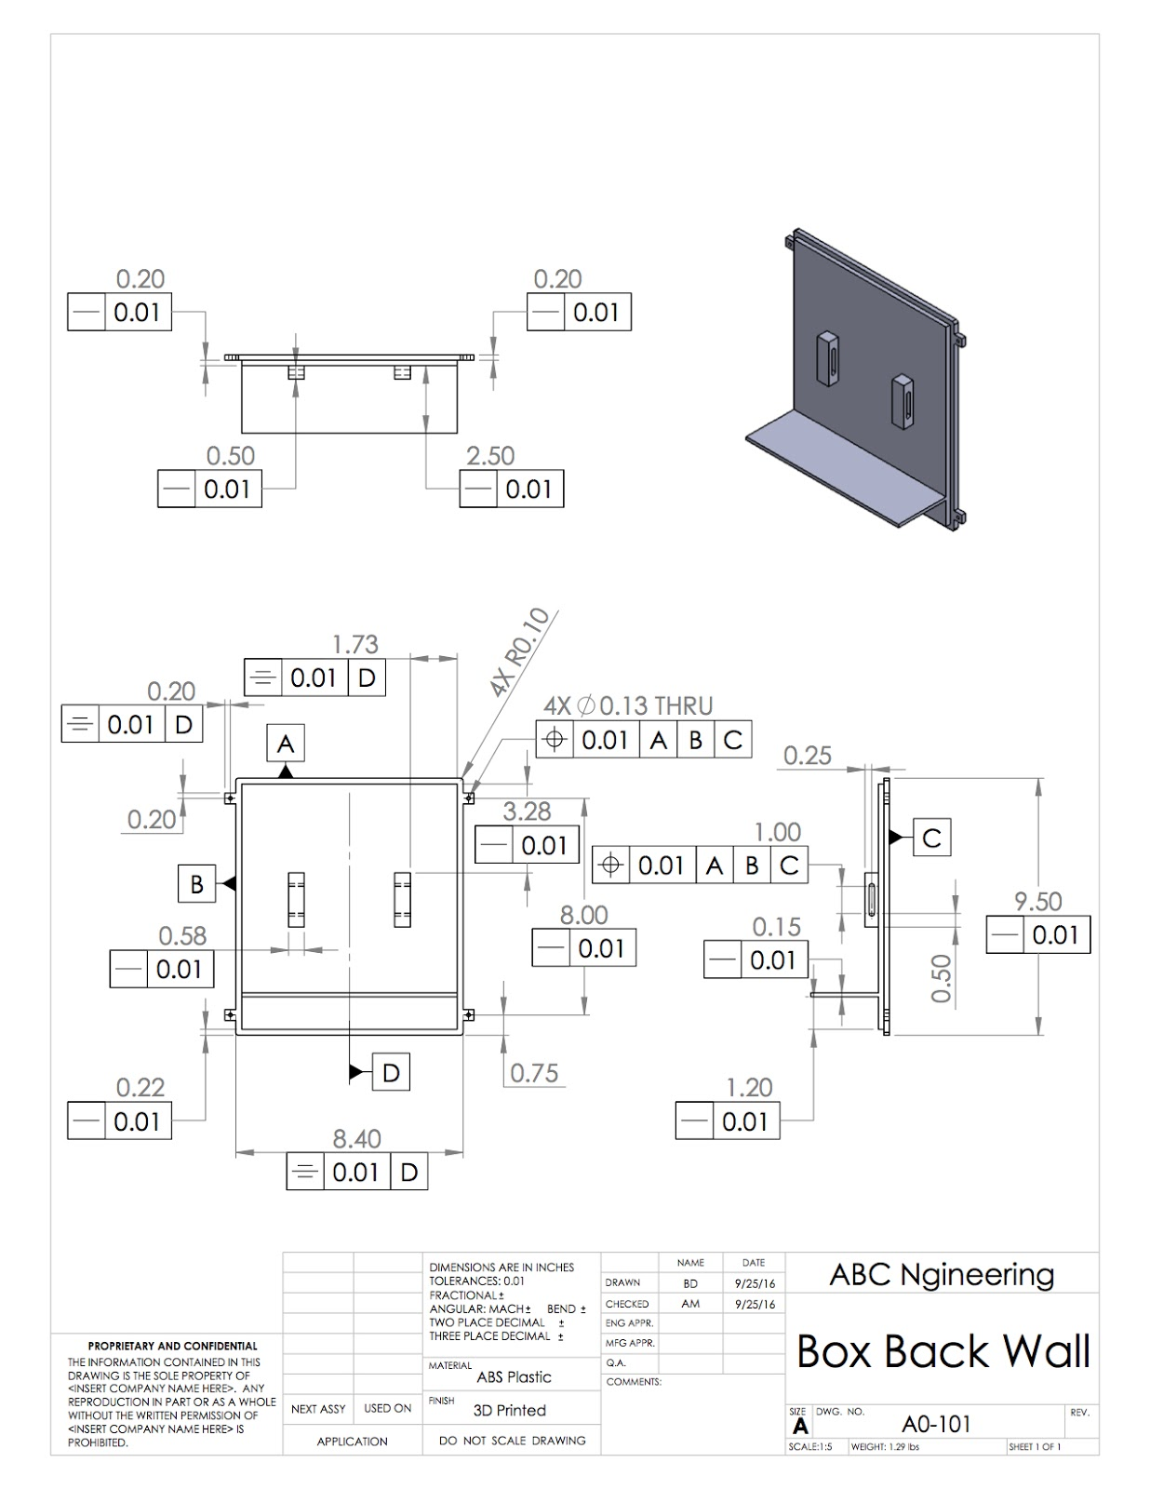

**Figure 9. Box Back Wall**

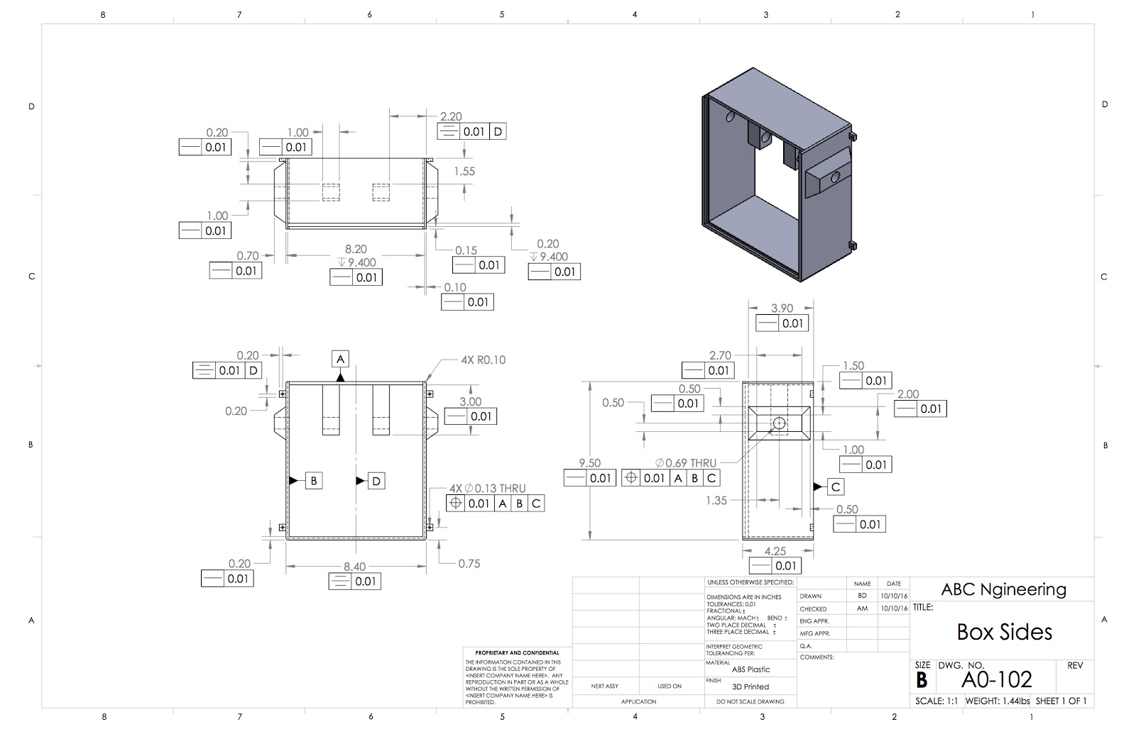

**Figure 10. Box Sides**

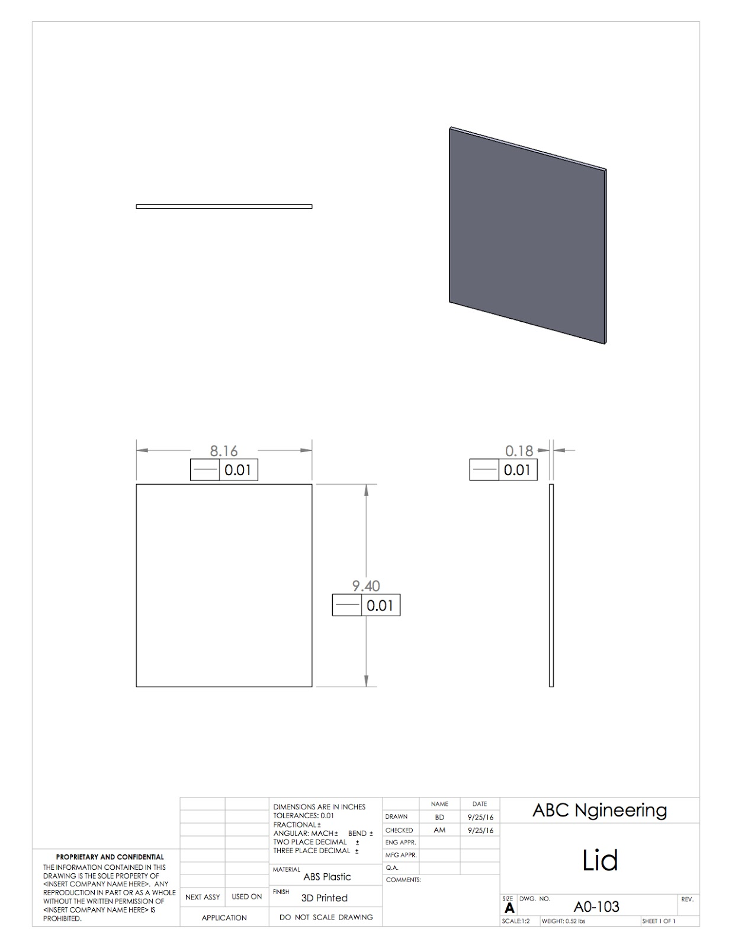

**Figure 11. Lid**

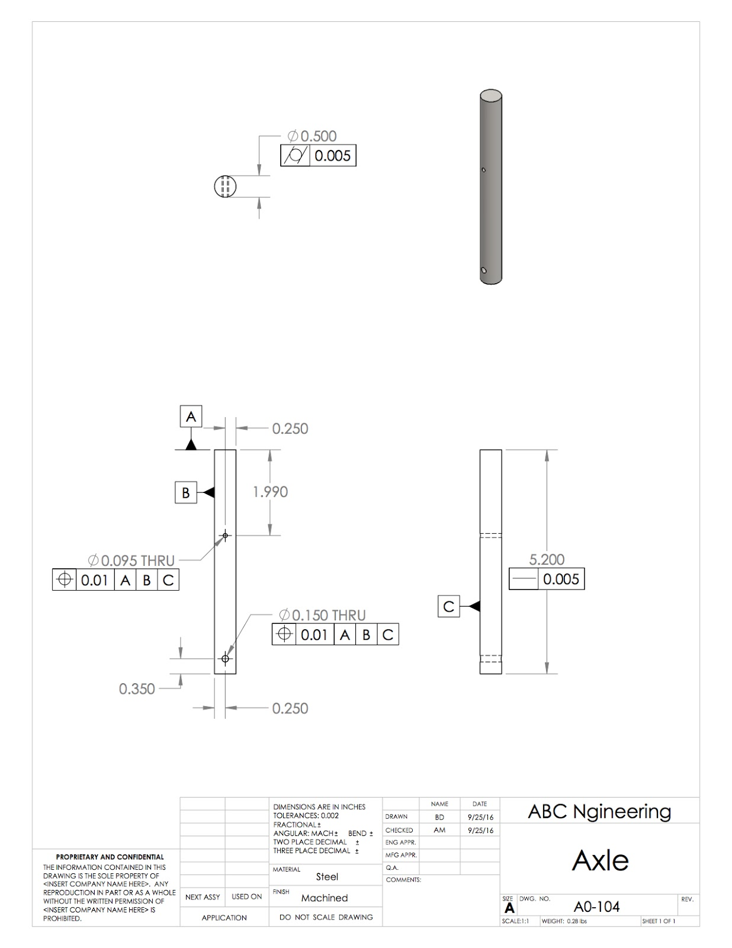

**Figure 12. Axle**

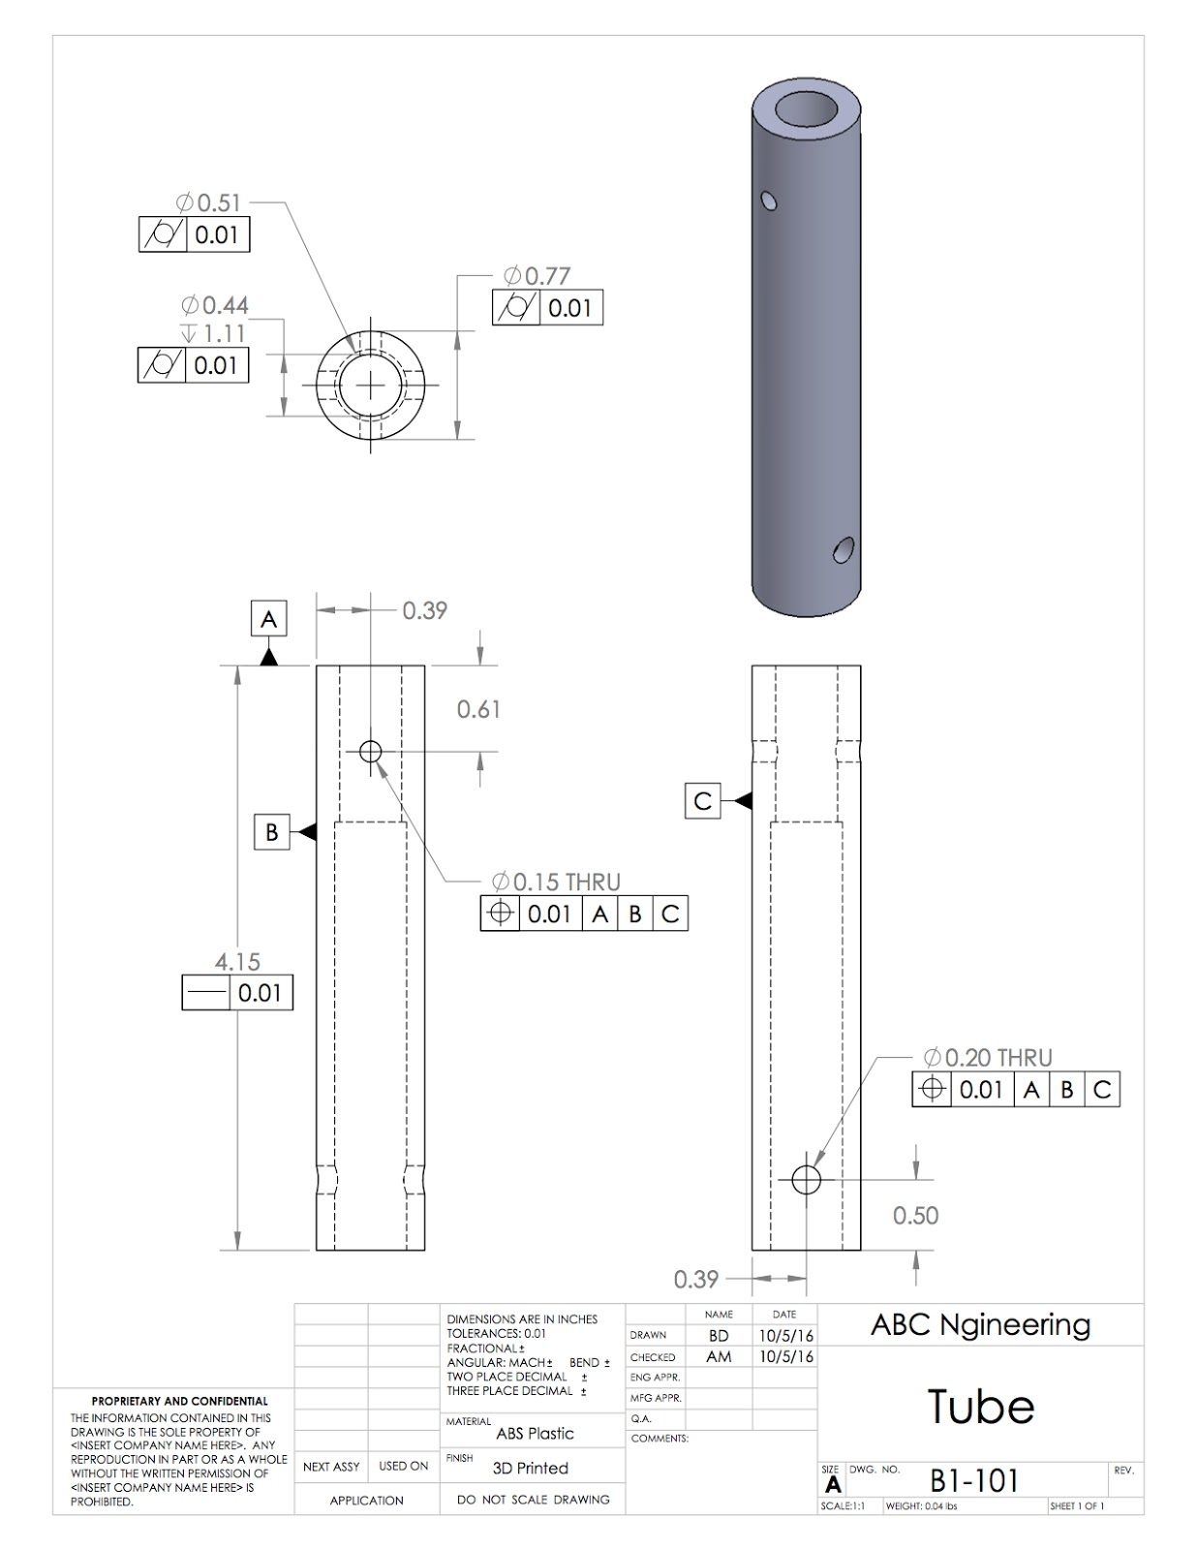

**Figure 13. Leg Tube**

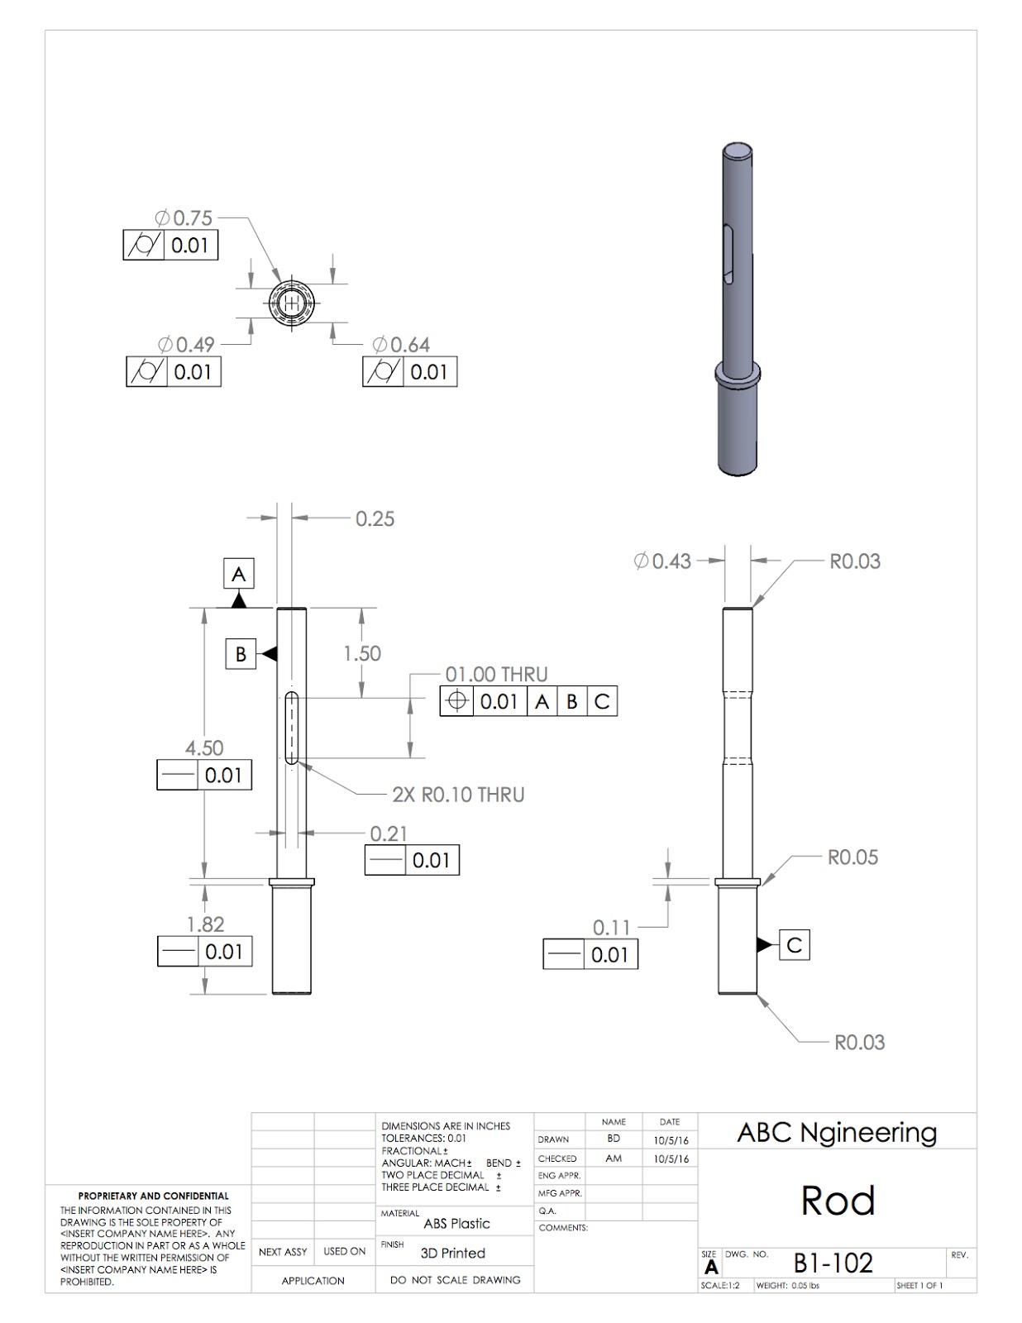

**Figure 14. Leg Rod**

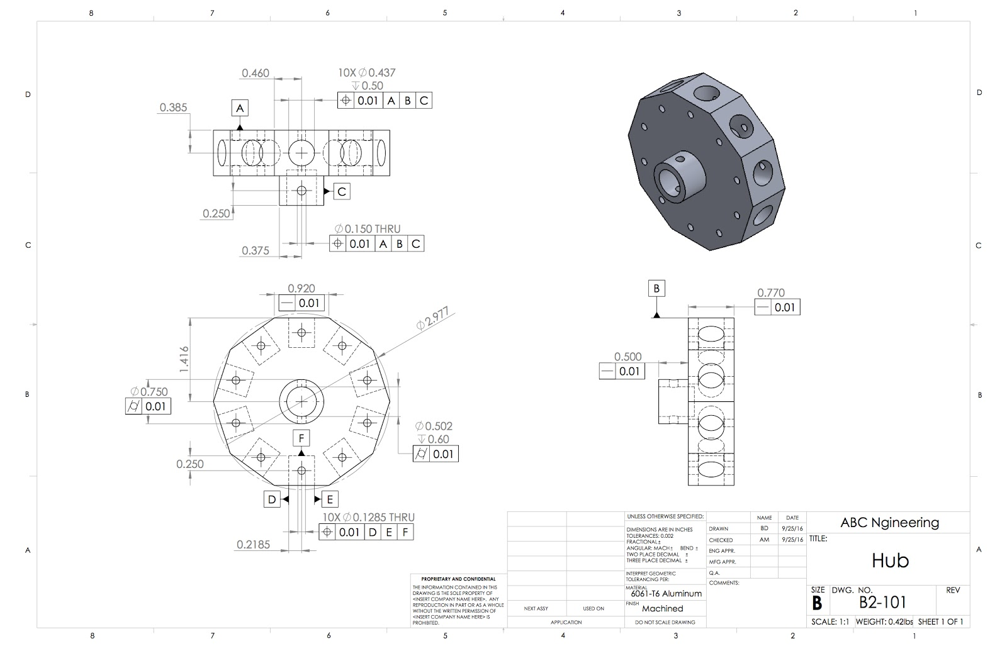

**Figure 15. Hub**

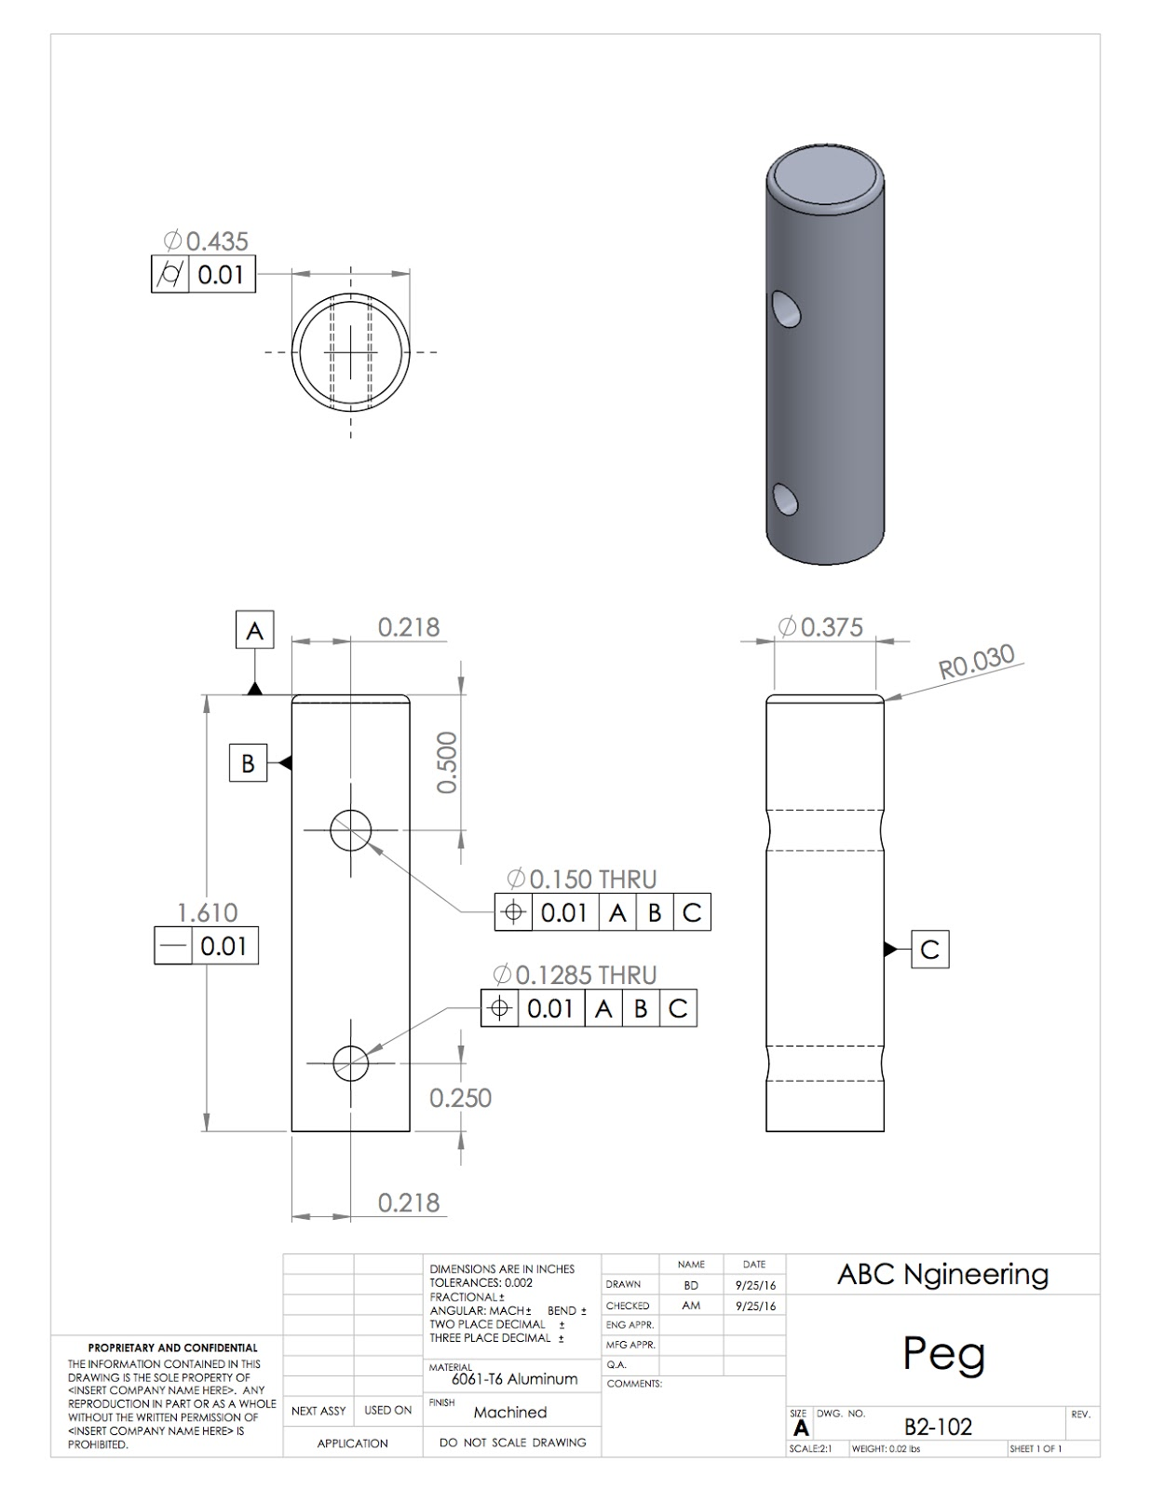

**Figure 16. Peg**

# Appendix E - Calculations

# Calculations

## Equation 1. Concept 1 Turning Radius Calculations

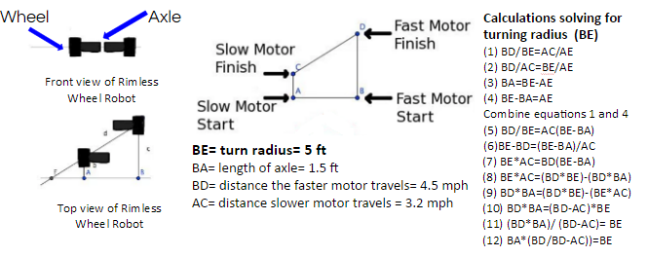

## Equation 2. Concept 2 Turning Radius Calculations

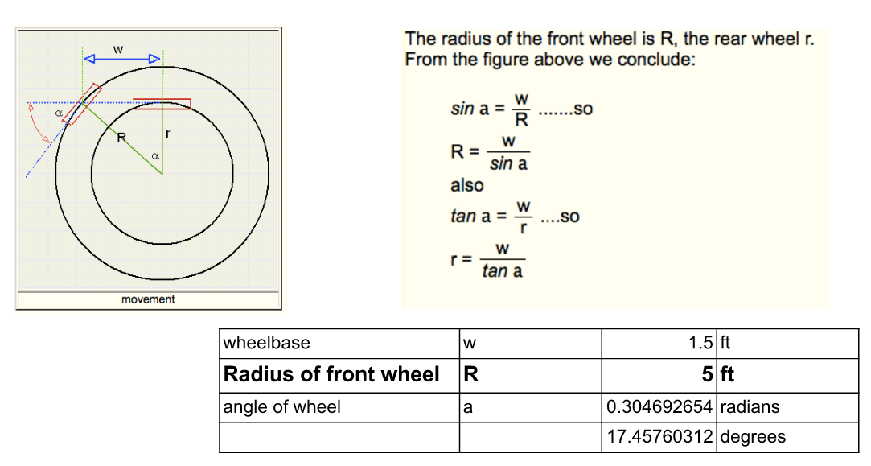

## Equation 3. Concept 3 Turning Radius Calculations

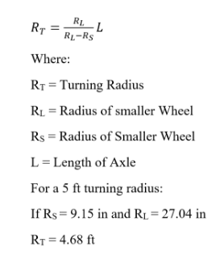

## Equation 4. Speed Calculations

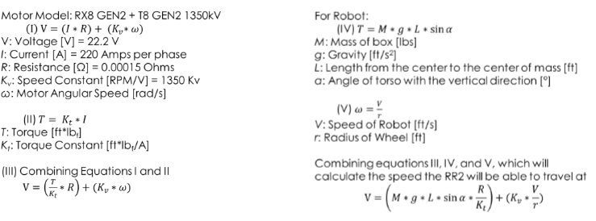

## Equations 5 and 6. Mass Moment of Inertia

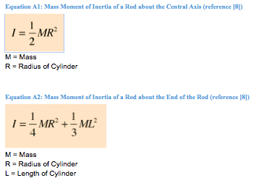

## Equation 7. Angular Velocity

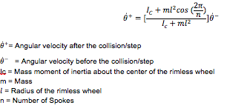

## Equation 8. Rotational Energy

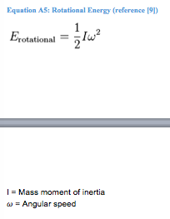

## Equation 9. Estimated Battery Usage Calculations

Estimated Time = Battery Capacity (Ah) / Current Used (A)

Battery Capacity = 3000 mAh

Current Used 7A

Estimated Time = 3/7 (h) = approximately 25 minutes

## Table 11. Moment of Inertia

|  |  |
| --- | --- |
|  | **Moment of Inertia(lbm*in^2)** |
| **Rod about central axis** | 0.028 |
| **Rod about its end** | 11.828 |
| 3 spokes per side | 30.750 |
| 4 spokes per side | 37.058 |
| 5 spokes per side | 43.365 |
| 6 spokes per side | 49.673 |
| 7 spokes per side | 55.980 |
| 8 spokes per side | 62.288 |
| 9 spokes per side | 68.595 |
| 10 spokes per side | 74.903 |
| 11 spokes per side | 81.210 |
| 12 spokes per side | 87.518 |
| 13 spokes per side | 93.825 |
| 14 spokes per side | 100.133 |
| 15 spokes per side | 106.440 |
| 16 spokes per side | 112.748 |
| 17 spokes per side | 119.055 |
| 18 spokes per side | 125.363 |
| 19 spokes per side | 131.670 |
| 20 spokes per side | 137.978 |

**Table 12. Angular Velocity**

|  |  |  |  |  |  |  |  |  |  |  |
| --- | --- | --- | --- | --- | --- | --- | --- | --- | --- | --- |
| **# Spokes** | **Inital Angular Velocity (rad/sec)** | **Mass (lbm)** | **Radius of Rim (in)** | **Mass Moment of Inertia About Center of Wheel (lbm*in^2)** | **Final Angular Velocity (rad/sec)** | **Inital Energy (in-lb)** | **Final Energy (in-lb)** | **Energy Lost (in-lb)** | **Percent of Energy Remaining** | **Percent Energy Remaining/Mass (1/lb)** |
| 3 | 7.333 | 0.9214 | 10 | 30.7500 | -0.9142 | 2.1414 | 0.0333 | 2.1081 | 1.55% | 0.0169 |
| 4 | 7.333 | 1.1104 | 10 | 37.0575 | 1.8349 | 2.5806 | 0.1616 | 2.4190 | 6.26% | 0.0564 |
| 5 | 7.333 | 1.2994 | 10 | 43.3650 | 3.5339 | 3.0199 | 0.7013 | 2.3185 | 23.22% | 0.1787 |
| 6 | 7.333 | 1.4884 | 10 | 49.6725 | 4.5839 | 3.4591 | 1.3517 | 2.1074 | 39.08% | 0.2625 |
| 7 | 7.333 | 1.6774 | 10 | 55.9800 | 5.2629 | 3.8983 | 2.0080 | 1.8903 | 51.51% | 0.3071 |
| 8 | 7.333 | 1.8664 | 10 | 62.2875 | 5.7226 | 4.3376 | 2.6417 | 1.6959 | 60.90% | 0.3263 |
| 9 | 7.333 | 2.0554 | 10 | 68.5950 | 6.0467 | 4.7768 | 3.2480 | 1.5289 | 67.99% | 0.3308 |
| 10 | 7.333 | 2.2444 | 10 | 74.9025 | 6.2830 | 5.2161 | 3.8292 | 1.3869 | 73.41% | 0.3271 |
| 11 | 7.333 | 2.4334 | 10 | 81.2100 | 6.4602 | 5.6553 | 4.3892 | 1.2661 | 77.61% | 0.3189 |
| 12 | 7.333 | 2.6224 | 10 | 87.5175 | 6.5964 | 6.0945 | 4.9316 | 1.1629 | 80.92% | 0.3086 |
| 13 | 7.333 | 2.8114 | 10 | 93.8250 | 6.7032 | 6.5338 | 5.4597 | 1.0741 | 83.56% | 0.2972 |
| 14 | 7.333 | 3.0004 | 10 | 100.1325 | 6.7885 | 6.9730 | 5.9760 | 0.9971 | 85.70% | 0.2856 |
| 15 | 7.333 | 3.1894 | 10 | 106.4400 | 6.8577 | 7.4123 | 6.4825 | 0.9298 | 87.46% | 0.2742 |
| 16 | 7.333 | 3.3784 | 10 | 112.7475 | 6.9145 | 7.8515 | 6.9809 | 0.8706 | 88.91% | 0.2632 |
| 17 | 7.333 | 3.5674 | 10 | 119.0550 | 6.9617 | 8.2908 | 7.4725 | 0.8183 | 90.13% | 0.2527 |
| 18 | 7.333 | 3.7564 | 10 | 125.3625 | 7.0014 | 8.7300 | 7.9584 | 0.7716 | 91.16% | 0.2427 |
| 19 | 7.333 | 3.9454 | 10 | 131.6700 | 7.0351 | 9.1692 | 8.4394 | 0.7299 | 92.04% | 0.2333 |
| 20 | 7.333 | 4.1344 | 10 | 137.9775 | 7.0639 | 9.6085 | 8.9162 | 0.6923 | 92.80% | 0.2244 |

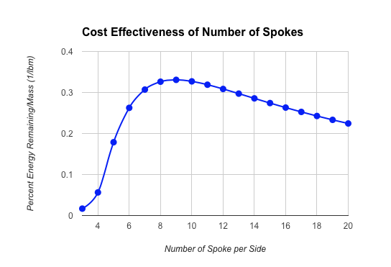

## Figure 20. Spoke Effectiveness

# Project Cost Analysis

## Equation 10. Schedule Variance

$$SV=BCWP-BCWS$$

Where SV = Schedule Variance

BCWP = Budgeted Cost of Work Produced

BCWS = Budgeted Cost of Work Scheduled

## Equation 11. Cost Variance

$$CV=BCWP-ACWP$$

Where CV = Cost Variance

BCWP = Budgeted Cost of Work Produced

ACWP = Actual Cost of Work Produced

## Equation 12. Schedule Performance Index

$$SPI=\frac{BCWP}{BCWS}$$

Where SPI = Schedule Performance Index

BCWP = Budgeted Cost of Work Produced

BCWS = Budgeted Cost of Work Scheduled

## Equation 13. Cost Performance Index

$$CPI=\frac{BCWP}{ACWP}$$

Where CPI = Cost Performance Index

BCWP = Budgeted Cost of Work Produced

ACWP = Actual Cost of Work Produced

## Equation 14. Cost Schedule Index

$$CSI=SPI⋅CPI$$

Where CSI = Cost Schedule Index

SPI = Schedule Performance Index

CPI = Cost Performance Index